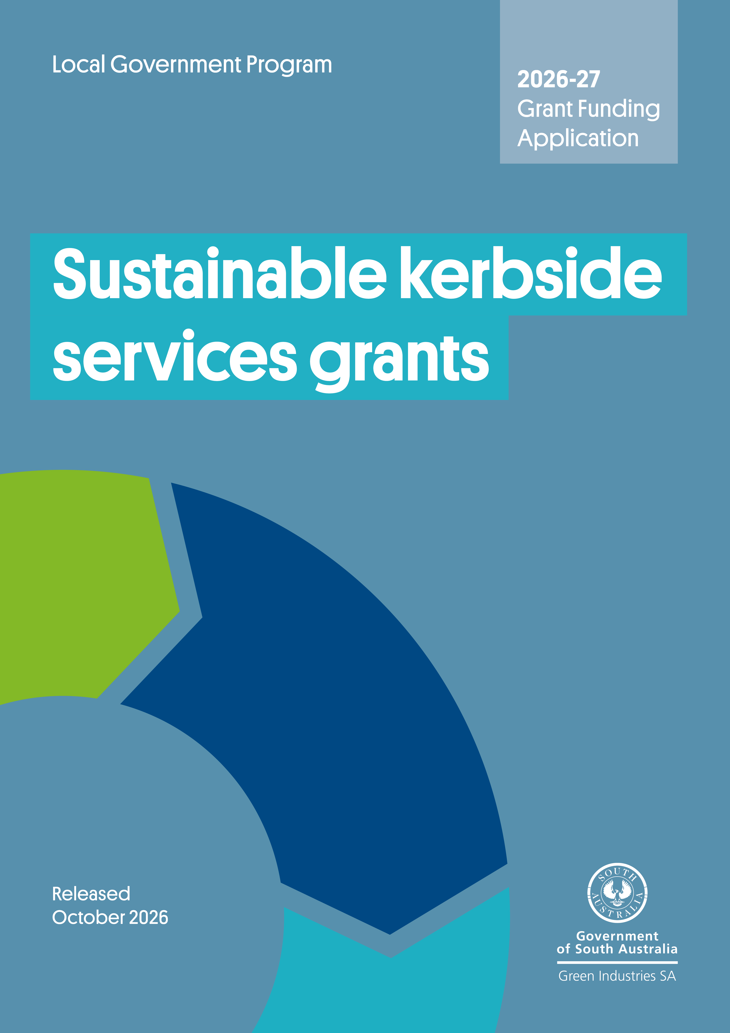

Contents
Program overview 4
Submitting your application 4
Need assistance? 4
Section A: General applicant information 5
Section B: Eligibility criteria checklist 6
Section C: Project proposal 7
Section D: Declaration 15

Acknowledgement of Country
Green Industries SA acknowledges and respects the Traditional Custodians whose ancestral lands we live and work upon, and pays respect to their Elders past, present and emerging.
We acknowledge and respect their deep spiritual connections, and the relationship that Aboriginal and Torres Strait Islander people have to Country.
We extend our respect to all Aboriginal and Torres Strait Islander peoples and their nations in South Australia, and across Australia.

Program overview
The purpose of the Sustainable Kerbside Service grant program is to encourage South Australian councils to improve waste management and recycling services by transitioning to, or introducing, kerbside collection services that increase resource recovery and reduce landfill disposal, aligned with SA Better Practice Guide: Sustainable Kerbside Service model. Processing of the collected organic materials into high-value soil improvement products is a core objective of this program and implementation of services must also support achievement of kerbside contamination targets outlined in the Strategy.

Submitting your application
Applications will be accepted until 5 pm ACDT, 4 December 2026.
Late applications will not be assessed.
Please email your completed application form, including a signed declaration, with all supporting documents to han.tran@sa.gov.au with the subject line ‘Sustainable Kerbside Service Grants 2026-27 – application – [applicant name]’.
Emails should not exceed 10MB and applications are to be no more than 20 pages (including supporting information). To reduce file size, the first 3 pages of this form may be deleted before submitting to GISA.
Before completing your application:
- Read the grant funding guidelines in detail. The guidelines have important information regarding eligibility, the application and assessment process, and funding conditions.
- Complete all relevant sections of the application form.
- Attach and clearly number evidence in support of the application.
- Understand that applying does not guarantee funding approval. Your application will be assessed for eligibility and alignment with assessment criteria published in the grant guidelines. Funds are awarded at the discretion of Green Industries SA (GISA), and in accordance with budget availability for applications that satisfactorily meet all eligibility criteria and pass assessment criteria.

Need assistance?
For further information, or to discuss your application and eligibility, contact Justin Lang at justin.lang@sa.gov.au or on 0419 948 931.
Requests for funding towards the cost of providing food waste systems (kitchen caddies and compostable bags) to households and small businesses should submit an application under the In-home Food Waste System Grants, as a separate (and complimentary) application (if applicable).

Section A: General applicant information
A1. Name of organisation
A2. Australian Business Number (ABN)
A3. Is your organisation (tick one):
The lead organisation of a consortium or partnership? |  | The sole applicant?
A4. If you are applying as the lead partner in this application, please give the names of the other organisations in the project and their roles.
A5. Applicant address
Street address:
Suburb: State: Postcode:
Your postal address (if different from your business address)
Street address:
Suburb: State: Postcode:
Website:
A6. Contact details:
Primary contact details: Person within the applicant organisation who will manage/oversee project delivery.
Full name: |  | Position:
Tel: |  | Mobile:
Email:
Secondary contact details: Person within the applicant organisation who will support project delivery.
Full name: |  | Position:
Tel: |  | Mobile:
Email:

Section B: Eligibility and assessment criteria checklist
Applications that do not meet the below criteria will not be assessed further.
To be eligible for funding the applicant must meet all eligibility criteria below | Yes | No
B1. Is the applicant a council or local government subsidiary established under the Local Government Act 1999 (SA)? | ☐ | ☐
B2. Is the applicant currently solvent, able to enter into a legally binding funding agreement with the Government of South Australia and expected to remain solvent for the duration of the agreement? | ☐ | ☐
B3. Does the applicant comply with all federal and state laws, regulations and any applicable Environment Protection Authority requirements? | ☐ | ☐
B4. The project requests no more than 50% funding contribution by GISA (excluding in-kind) or is eligible for a reduced co-contribution. | ☐ | ☐
B5. Does the proposed project meet and contribute to the objectives and aims of Accelerating SA’s transition to a circular economy: South Australia’s waste strategy 2025–2030 and the Sustainable Kerbside Service Grants for 2026-27. | ☐ | ☐
B6. Does the proposed project demonstrate the need for government funding for at least one of the eligible funding items under the Sustainable Kerbside Service Grants listed below?  - Staged, area-wide implementation of sustainable kerbside service  - Pilot of sustainable kerbside service  - Regional only - Pilot of other kerbside services or collection frequency (please specify) | ☐  ☐  ☐ | ☐  ☐  ☐
B7. The project is new or not already commenced (extensions of previous projects may be acceptable, provided the activities do not duplicate work previously undertaken) | ☐ | ☐
B8. GISA-approved (e.g. Which Bin) branded communications will be used for engagement activities, and the application provides details of the education and communications activities, including frequency and/or proposed timing. | ☐ | ☐
B9. Applicant has a documented process for management of households presenting bins with high contamination levels and for addressing contamination concerns when raised by collection providers, processing facilities, auditors or council staff to support the achievement of 2030 2% kerbside FOGO contamination target. | ☐ | ☐
B10. Number of households or serviced tenements for the collection service rollout is provided, supported by area maps and latest ABS data/rates data. | ☐ | ☐
B11. Application indicates the expected diversion potential of the proposed system. | ​​☐​ | ​​☐​
B12. Does the project have an experienced project manager assigned to oversee project delivery? | ☐ | ☐
B13. Does the project have a clear implementation timeframe and milestones? Will the project be delivered within the required timeframe? | ☐ | ☐
B14. Details of contractors and processors are clearly listed with appropriate licensing and evidence that products sold meet Australian Standard 4454-2012 and are or will be supplied to higher beneficial use end markets | ☐ | ☐
B15. Details of recognised higher-use end markets are clearly provided and are intended to remain valid for the duration of the proposed project | ☐ | ☐
B16. Applicant has committed to purchasing composts or other soil improvement products from the processing facility to support local re-circulation of nutrients and organic materials. | ☐ | ☐

Section C: Project proposal

C1. Project summary
Project title
If your application is successful, this title or a variation thereof may be used by GISA for promotional and/or reporting purposes
Project timeframe
Proposed start date: | Expected completion date:
Key project aim
Project type
Area-wide implementation (roll-out) of sustainable kerbside service. Applications for a this to be done via a staged approach within three years will be accepted.  If applying for the above, is the applicant also seeking funding for a dedicated position to support staged, area-wide implementation of sustainable kerbside service, for a period of up to 12 months?  ☐ Yes ☐ No |  | ☐
Pilot of sustainable kerbside service |  | ☐
Regional only - Pilot of other kerbside services or collection frequency (please specify) |  | ☐
Project details and rationale
Please describe the project in more detail, including why it is needed, what specific objectives it seeks to achieve, and the expected outcomes – particularly economic, environmental, or social benefits.

C2. Details of proposed kerbside collection system
Number of serviced properties the sustainable kerbside system collection model will be provided to: |  | [number] households  (round to nearest 100) | [number] commercial premises  (round to nearest 50)
Default collection frequency:  Organics  Comingled recyclables  General waste |  | ☐ Weekly ☐ Fortnightly  ☐ Weekly ☐ Fortnightly  ☐ Weekly ☐ Fortnightly
 | Has this application been submitted concurrently with an application for the In-home Food Waste System Grant? ☐ Yes ☐ No
What is council’s current disposal cost/tonne for residual waste? $ per tonne
(please indicate if including or excluding solid waste levy)

What is council’s current processing cost/tonne for organics? $ per tonne
Expected landfill diversion outcomes of the proposed system: tonne per annum

C3. Proposed implementation process
Action summary  (the items listed below are a guide only and can be adjusted to align with the project proposal) | Estimated date (mm-yyyy)
Planning and approval
Order bins and food waste containers (where applicable)
Design of education material
(contact GISA for customised Which Bin or other appropriately branded materials)
Initial communication to residents (e.g. council newsletter)
Printing education materials
Distribution of bins to households (where applicable)
Commencement of new collection arrangements

Please outline how education material and communications will be delivered to households ahead of the trial, including intended timing (Further details can be provided in Section C7).
Please outline how households that are wishing to opt out of the default collection service will be managed to maximise the use of the sustainable collection service.
Please outline the process for management of households that present organic bins with high contamination levels, including those that have not opted out of the default weekly FOGO collection service. The response should detail how contamination will be identified, monitored and addressed (e.g measures for repeat contamination).
Please outline how achievement of the 2030 2% kerbside FOGO contamination target in the Strategy will be supported and how contamination concerns raised by collection providers, processing facilities or other stakeholders will be addressed.

C4. Proposed budget (itemise all expenditure items)
List items required for the project (excluding in-kind contributions, these should be added to the next table). Insert additional rows if required.
Funding from Green Industries SA is available as a co-contribution of up to 50% of total project costs from sources other than the South Australian and Australian governments, and not including ‘in-kind’ (non-financial), up to:
- $300,000 for area-wide implementation of sustainable kerbside service (including staged rollout),
OR
- $100,000 for other eligible projects under this program.

Applicants eligible for a reduced co-contribution may request funding of over 50% total project costs where sufficient justification and supporting evidence can be demonstrated.

For area-wide implementation of sustainable kerbside services, funding may be sought as a 50% contribution towards the cost of a dedicated position (staff) to support the implementation of area-wide roll-out, for a period of up to 12 months.

Staffing costs for pilots / trials are ineligible for grant funding.

Please include detailed quotes for any goods and services to be procured where applicable, noting quotes must include suppliers’ details including ABN and any GST component.

Expenditure item | Delivery date  (estimated) | GISA funding sought  ($) | Applicant contribution  ($) | Total cost of project  ($) (ex GST)
Totals (sum of amounts above the line) |  | $ | $ | $
% Total cash funding |  | % | % | %
Justification for reduced co-contribution request (if eligible and applicable):

Other funding source
Any other grants or funding that the applicant, partners, and sub-contractors for this application have or will receive relating to the activities proposed in this project.
Project activities/element | Organisation providing other funding/payment |  | Contact details for organisation | Amount of funding/payment |  | Relationship to this project
 |  |  |  | $
 |  |  |  | $
 |  |  |  | $
Please provide a breakdown of any in-kind contributions
Project element |  | Organisation providing in-kind contribution |  |  | Value of in-kind contribution
 |  |  |  |  | $
 |  |  |  |  | $
 |  | Total value of in-kind contribution |  |  | $
 |  | Total project budget |  |  | $

C5. Council approval and budget allocations
If your application is successful, you will need to provide details of an appropriate organisational approval (e.g. council resolution) and reports within 3 months of receiving the initial notification or within 3 months of the signing of the grant agreement (as determined in writing between successful applicants and GISA), and before grant funds are released.

If already obtained, please attach a copy.
Has council obtained approval to:
- support implementation of area-wide kerbside food organics collections systems or increased frequency of organics collections aligned with the Sustainable Kerbside Service model
☐ Yes ☐ No
OR
- support implementation or pilot of kerbside system or collection frequency proposed in this application ☐ Yes ☐ No

If ‘Yes’, please include details of the approval below and attach a copy of the report as part of the application.

If ‘No’, when is the approval likely to be provided? (please detail below)

C6. Contracts for collection and processing
Name of collection contractor:

Collection contractor EPA license number:
Contract in place for collection of proposed system: ☐ Yes ☐ No |  | Expiry date:
Name of licenced recycling/organics processor
Processing site:
Processor EPA license number:
Contract in place to accept organics and recyclables materials from council? ☐ Yes ☐ No
Contract expiry date:

End markets where processed material is sent for higher-end beneficial reuse:
Please attach evidence of processed materials being supplied to higher-use end markets. Evidence can include email or other document from the processing facility or business confirming the material received and its use.

Recycling and reprocessing facilities that are certified to a recognised standard or accreditation (e.g. GECA) will be highly regarded.

Please provide evidence of the commitment by applicant to purchasing composts or other soil improvement products from the processing facility. This should include information on:
- the estimated tonnage, product type, intended use and purchase timeframe for composts or other soil improvement products
- any planned community initiatives to support local recirculation of recovered organic materials.

C7. Communication and consultation
Has a communications plan been prepared? | ☐ Yes, (please include/attach) | ☐ No
Please detail what community consultation has/will occur:
Please indicate below what efforts council will be putting into education for the term of the agreement with GISA.

☐ Regular features in council newsletters or local papers
☐ Web-based waste reduction information
☐ Community education brochure
☐ Social media
☐ Which Bin resources requested (brochure, rates insert, DL fridge magnet, social media tiles)
☐ Other (please specify)

C8. Capacity and capability to manage the project
Please explain and demonstrate applicant and sub-contractors (if applicable) capacity and capability to manage and deliver the project successfully. Please add rows if needed.
Name:
Position:
Role in this project:
Relevant experience/expertise:

Name:
Position:
Role in this project:
Relevant experience/expertise:

Where an applicant wishes to seek funding support for a dedicated position for the area-wide roll-out / implementation of Sustainable Kerbside Service, please detail the scope of works below.

Please note funding is available for up to 50% for a period of up to 12 months to support the position.
Name:
Current position (if nominated position is to be filled by an existing council staff):
Proposed start date: Proposed end date:
Role/duties:

Relevant experience/expertise/qualifications:

Please detail the salary/FTE/contact hours required for the nominated position:

What outcomes will be delivered?

Please detail the position’s scope of work and work plan (may be attached separately)

C9. Project milestones
Please outline project milestones and key activities (add more rows as required)

 | Milestone and key activities | Start date  (dd/mm/yy) | Completion  (dd/mm/yy)
1 | Milestone title:  Key tasks/activities:
2 | Milestone title:  Key tasks/activities:
3 | Milestone title:  Key tasks/activities:

C10. Monitoring and evaluation
Please list project key performance indicators (KPIs), how they will be measured (what data will be captured/what’s the unit of measurement) and a target (goal) for each in the table below.

At least one of the KPIs must support the 2030 2% kerbside FOGO contamination target outlined in the Strategy and one KPI must demonstrate the applicant’s commitment to purchasing composts or other soil improvement products from the processing facility to support local circular economy outcomes.

 | KPI | How it will be measured | Target
1
2
3

C11. Project risk management (refer to Appendix A)
D 10. Project risk management
Please identify and describe the key risks associated with the project, along with the proposed mitigation measures. For guidance on likelihood, consequences, and risk ratings, refer to Appendix A: Guidance on Risk Assessment on the program webpage. (Add more rows as required)
 | Risk short name | Risk description | Likelihood | Consequences | Inherit risk rating | Control/mitigation strategy | Residual likelihood | Residual consequences | Residual risk rating
1
2
3
4
5
6

Section D: Declaration

Application checklist

☐ | Completed all relevant sections of the application form in full
☐ | Included detailed quotes for any goods and services to be procured, noting quotes must include suppliers’ details including ABN and any GST component
☐ | Attached all supporting documents, such as council approval or resolution documents, if applicable
☐ | Included identification of the main risks associated with the project and the proposed mitigation measures (demonstrating appropriate project risk management)
☐ | Included appropriate key performance indicators, and information on their measurement, evaluation and data capture
☐ | Signed the declaration (ensuring it is signed by an authorised officer)

Declaration
- I have read and understood the guidelines and obtained clarification where needed.
- I declare that the information provided in this application including attachments is to the best of my knowledge true and correct and discloses all required and relevant details. I understand that if information supplied as part of the application is false or misleading in a material particular, the application will not be considered OR, if the grant is made and it is discovered that information supplied was false or misleading in a material particular, the grant will be revoked and funds must be repaid. An assessment regarding possible fraud will also be undertaken and appropriate legal action initiated if warranted.
- I declare that I/we have complied with federal and state laws, regulations, and the Environment Protection Authority licences (if any).
- I authorise Green Industries SA to seek any additional relevant information required to process this application, and I/we hereby request and authorise any parties to supply such information as requested.
- I understand that if the project is approved for funding, information of a non-sensitive and non-confidential nature about the project may be publicised by Green Industries SA or provided as required or permitted by law.
- If the project is approved for funding, I will obtain all necessary and appropriate clearances from the relevant federal, state or local governments before executing the grant agreement and undertake to manage the proposed project in accordance with relevant laws and regulations.
- I understand that submission of this application does not guarantee funding approval and that all applications are assessed by Green Industries SA against the assessment criteria, with funds allocated in accordance with assessment results and budget availability.
- If I accept an offer of funding, then I accept (jointly and severally in the case of a group application) responsibility for administering grant funds and liability in the event grant funds are to be repaid.
This declaration must be signed by an appropriately authorised representative of the applicant organisation, such as the Chief Executive, Executive Officer, Chairperson, or equivalent.
The signatory must hold sufficient authorisation to ensure the applicant complies with the points listed above and is able to approve/enter into an agreement with Green Industries SA should the application be successful.

Signed
Name
Position
Date

Section 10(2) of the Environment Protection (Waste to Resources) Policy 2010 requires metropolitan councils to provide a weekly general kerbside waste collection service (other than for recyclable waste or vegetative matter) in respect of residential premises within its area.
Total project budget is the total cost of the project plus in-kind contributions

