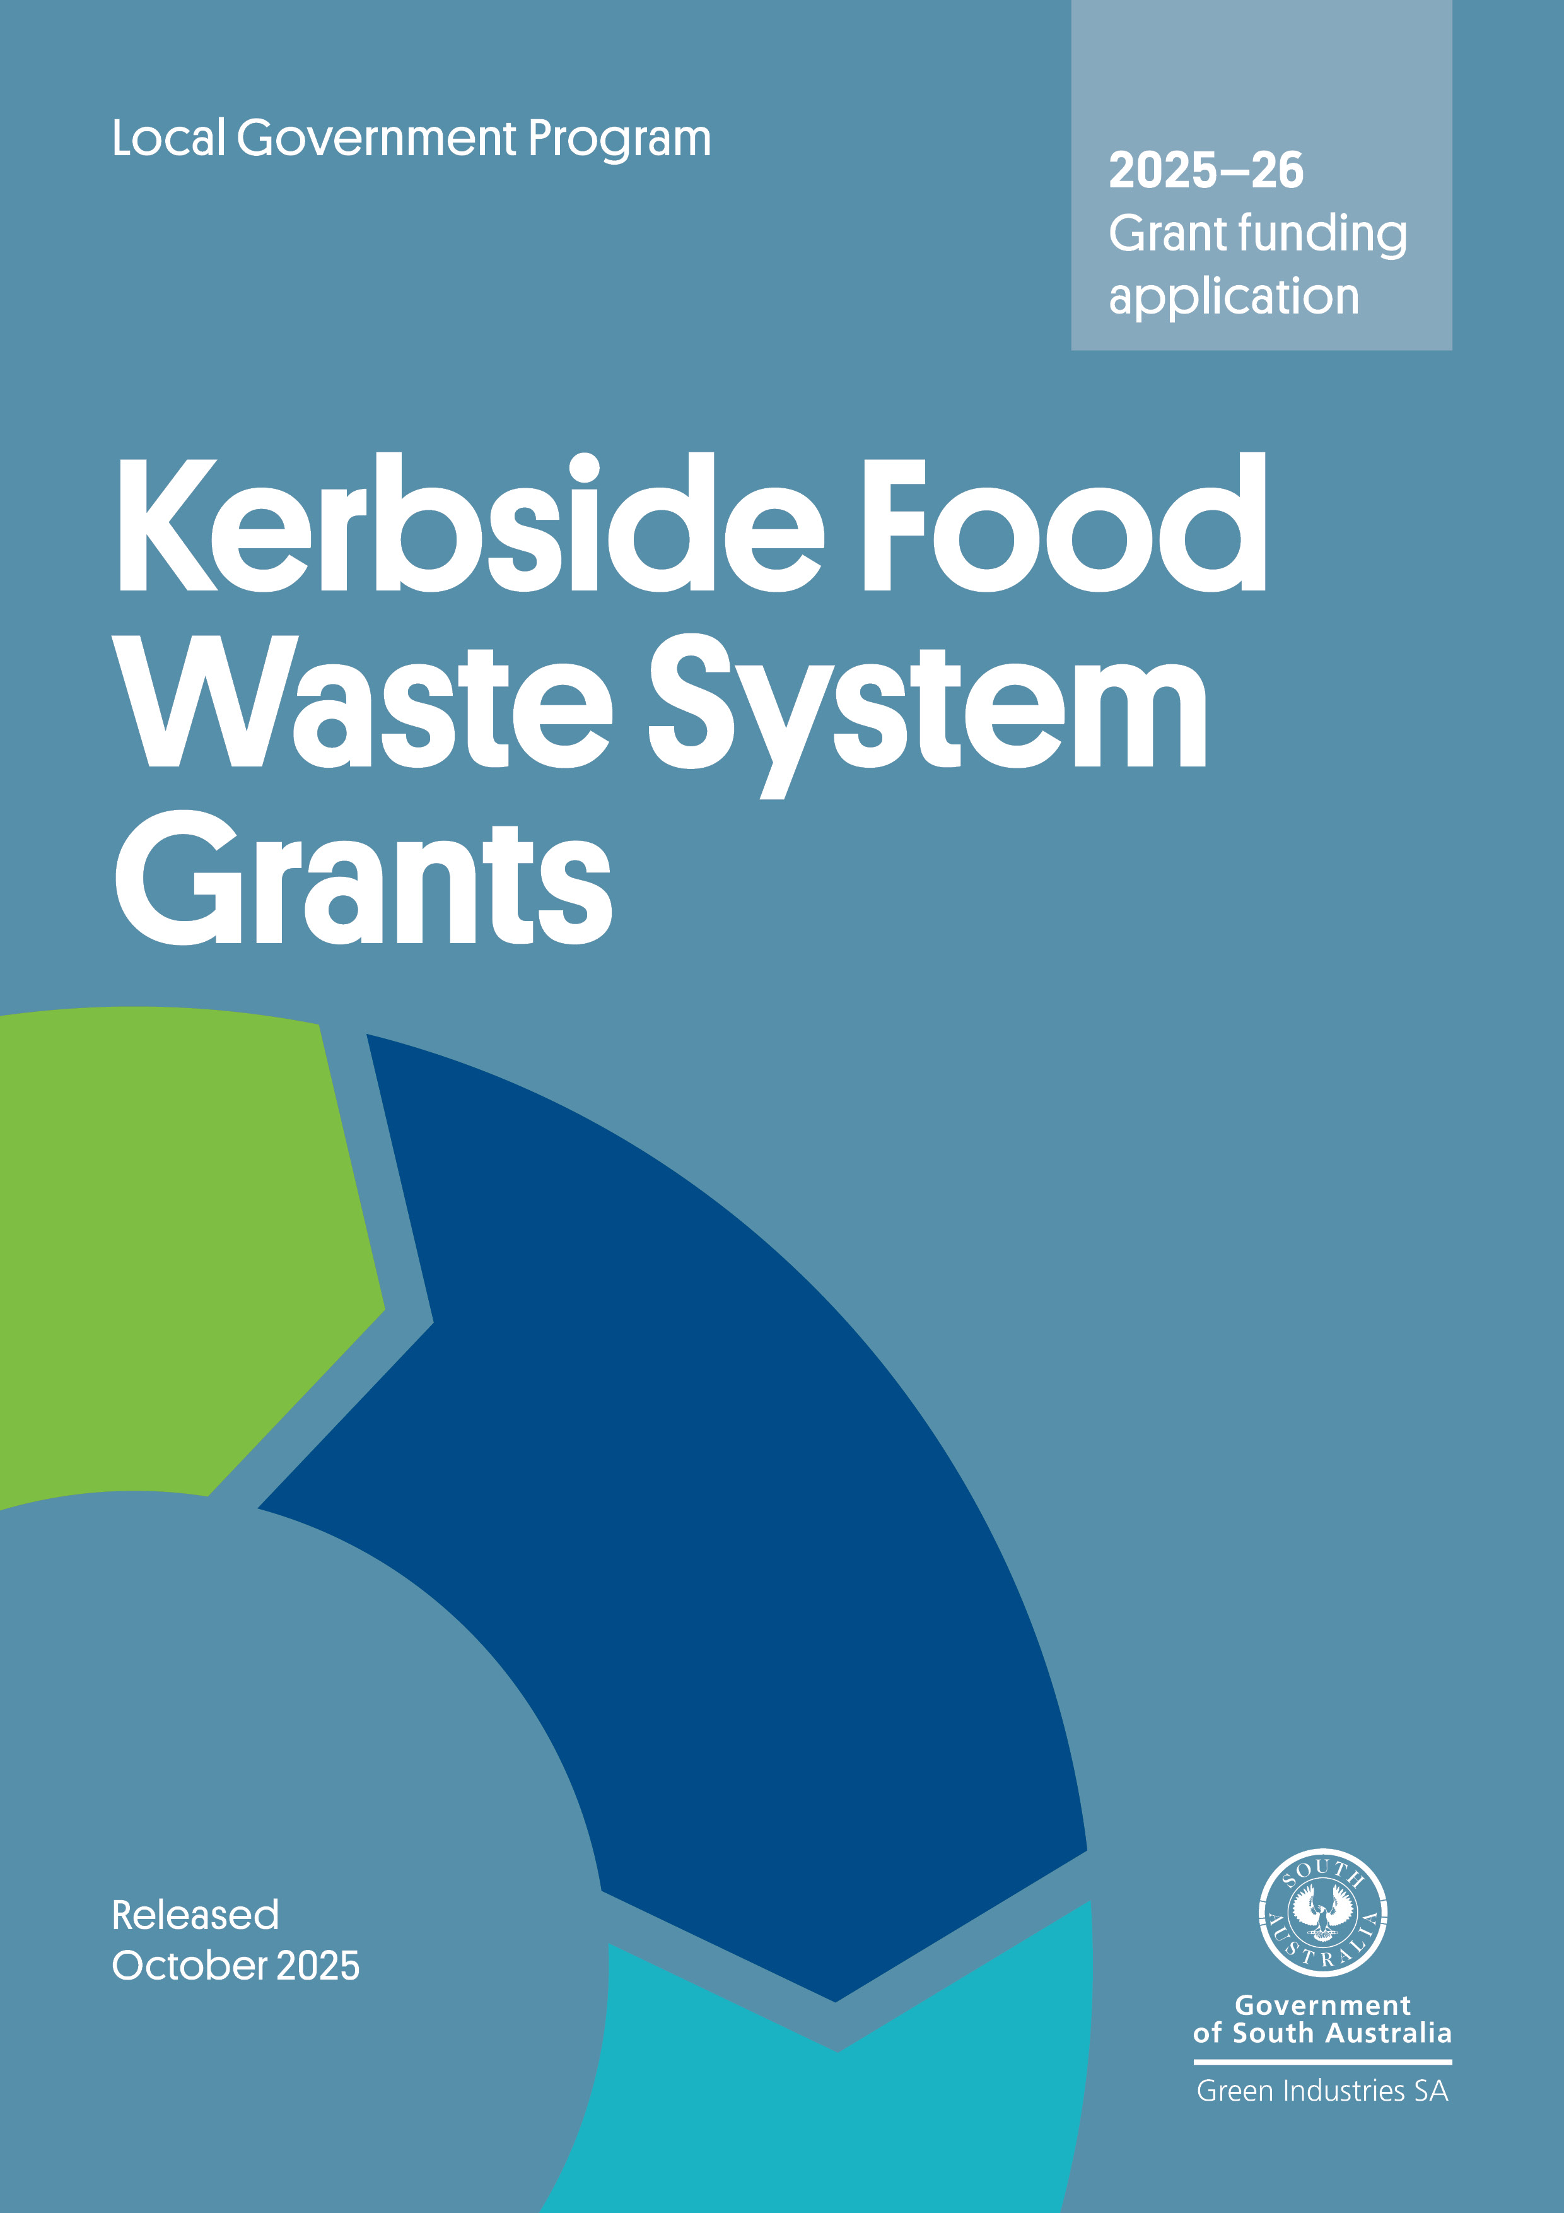

Contents
Program overview 3
Submitting your application 3
Section A: General applicant information 4
Section B: Eligibility criteria checklist 5
Section C: Details of proposed food waste system 5
Section D: Declaration 11
Appendix A – Guidance on risk assessment 13

Acknowledgement of Country
Green Industries SA acknowledges and respects the Traditional Custodians whose ancestral lands we live and work upon, and pays respect to their Elders past, present and emerging.
We acknowledge and respect their deep spiritual connections, and the relationship that Aboriginal and Torres Strait Islander people have to Country.
We extend our respect to all Aboriginal and Torres Strait Islander peoples and their nations in South Australia, and across Australia.

Program overview
Kerbside Food Waste System Grants assist councils to implement sustainable and efficient food waste recycling systems (caddies, liners and educational materials) for households and small businesses serviced by kerbside collection services. It recognises that disposing food to landfill represents the loss of a potentially valuable resource that can be circulated back into productive soils, and that when food waste is blended with kerbside green organic material, it improves the quality and nutrient value of the processed compost.

Submitting your application
Applications will be accepted until 5 pm ACDT, 7 November 2025.
Late applications will not be assessed. GISA has ultimate discretion in relation to management of late applications.
Please email your completed application form, including a signed declaration, with all supporting documents to justin.lang@sa.gov.au with the subject line ‘Kerbside Food Waste System Grants – application’. Emails should not exceed 10MB.
Applications are to be no more than 20 pages including supporting information.

Before completing your application:
- Read the grant funding guidelines in detail. The guidelines have important information regarding eligibility, the application and assessment process, and funding conditions.
- Understand that applying does not guarantee funding approval. Your application will be assessed for eligibility and alignment with assessment criteria published in the grant guidelines. Funds are awarded at the discretion of Green Industries SA (GISA), and in accordance with budget availability for applications that satisfactorily meet all eligibility and assessment criteria.

Need assistance?
For further information, or to discuss your application and eligibility, contact Justin Lang at justin.lang@sa.gov.au or on 0419 948 931.
Councils considering implementing pilots of alternative kerbside organic collections models under the Council Modernisation grant program should submit an application under this program concurrently to request funding to cover the cost of food waste systems provision to households and small businesses (if applicable).
Regional councils seeking assistance with area-wide distribution of green organics bins as well as food waste containers for use in households and businesses and compostable bin liners are encouraged to make contact.

Section A: General applicant information
A1. Name of organisation
A2. Business registrations
Australian Business Number (ABN):
A3. Is your organisation (tick one):
The lead organisation of a consortium or partnership? |  |  |  | The sole applicant?
A4. If you are applying as the lead partner in this application, please give the names of the other organisations in the project.
A5. Business address and postal address
Street address:
Suburb: State: Postcode:
Postal address for correspondence (if different from your business address)
Street address:
Suburb: State: Postcode:
Website:
A6. Contact details:
Primary contact details: Person within the applicant organisation who will manage/oversee project delivery.
Full name: |  | Position:
Tel: |  | Mobile:
Email:
Secondary contact details: Person within the applicant organisation who will support project delivery.
Full name: |  | Position:
Tel: |  | Mobile:
Email:

Section B: Eligibility criteria checklist
Applications that do not meet the below criteria will not be assessed further.
To be eligible for funding the applicant must meet all eligibility criteria below | Yes | No
Applicant is a South Australian council or subsidiary under the Local Government Act 1999 | ☐ | ☐
The project requests no more than 50% funding contribution by GISA , excluding in-kind and initial supply of compostable bags. | ☐ | ☐
Which Bin branded communications will be adapted for use with regular and ongoing communication proposed | ☐ | ☐
Application indicates the expected diversion potential of the proposed system. | ☐ | ☐
Correct number of houses as per ABS data/latest rates data | ☐ | ☐
The project uses proven systems or systems that have been successfully demonstrated, including ventilated cadies and AS certified compostable liners. | ☐ | ☐
The application is complete and quotes have been provided for materials, according to council’s purchasing policy | ☐ | ☐
The project has a clear timetable for rollout, and an experienced project manager is assigned to manage project delivery. | ☐ | ☐
Proposed system is congruent with program guidelines and priorities for this round | ☐ | ☐
Details of contractors, processors and end markets are clearly listed | ☐ | ☐

Section C: Details of proposed food waste system
Container manufacturer (supplier):  Contact details for supplier: | Name:  Address:  Phone:
Container type: | Ventilated (requiring compostable liner bags) | Non-ventilated (low priority in this round)
Number of services to be provided: | , households  (round to nearest 100) | , commercial premises  (round to nearest 50)
Estimated cost per container: | $ | Capacity: Litres
Was this price sought through a competitive tender process? | Yes, please provide details below of tender | No, please detail selection process to be undertaken
Tender/selection process:
What is council’s current disposal cost/tonne for residual waste? $
(indicate if including or excluding solid waste levy)
What is council’s current processing cost/tonne for organics? $

C2. Proposed budget (itemise all capital expenditure items)
Expenditure Item | Anticipated order date | Funding sought  (no more than 50% unless liner bags) | Applicant contribution | Other funding sources (please specify below) | Total cost
Description | (mm-yyyy) | $ ex GST | $ ex GST | $ ex GST | $ ex GST
Containers
Certifed compostable liner bags (if required) |  |  | N/A
Education material – brochure
Education material – stickers/prompts
Distribution
Other (please specify)
Totals: |  | $ | $ | $ | $
GISA funding as % of total funding:
Other funding sources:

C3. Project summary
Please give a short description of the project (including method of providing bags and containers where required).

C4. Council approval and budget allocations
If your application is approved, y
ou will need to provide details of council resolutions and reports within 3 months of the signing of contracts, and before grant funds are released. If already obtained, please attach a copy.
Has council resolved to introduce a food waste system?  If no, when is the resolution likely to be provided? (please detail below) | Yes | No
If yes, have you included details of the resolution and report? | Yes | No

C5. Implementation timeline
Action | Estimated date (mm-yyyy)
Order containers
Design of education material (contact GISA for customised Which Bin templates)
Initial communication to residents (e.g. council newsletter)
Printing education materials
Shipping (delivery to central location)
Assembly and distribution of containers
Start collections

C6. Contracts for collection and processing
Name of collection contractor:

Collection contractor EPA license number:
Contract in place for collection of organics: Yes/ No | Yes | Expiry date:
Name of licenced organics processor and processing site:

Organics processor EPA license number:
Contract in place to accept organics? Yes/ No | Yes | Expiry date:
End markets where composted material is sent:

C7. Communication and consultation
Has a communications plan been prepared? | Yes, (please include/attach) | No
Please detail what community consultation has/will occur:
Please indicate below what efforts council will be putting into education for the term of the agreement with GISA.
Regular features in council newsletters | Composting workshops
Web-based waste reduction information | Regular ads in local papers
Community education brochure | Social media
Tours of composting facilities | Other (please specify)
Which Bin resources requested (brochure, rates insert, DL fridge magnet, social media tiles)

C8. Project team experience
Demonstration of technical expertise and capacity to manage project (1 to 2 staff)
(100 characters except relevant experience – 250 characters)
Name:
Position:
Role in this project:
Relevant experience/expertise:

Name:
Position:
Role in this project:
Relevant experience/expertise:

C9. Project milestones
Please outline project milestones and key activities (add more rows as required)
 | Milestone and key activities | Start date  (dd/mm/yy) | Completion  (dd/mm/yy)
1 | Milestone title:  Key tasks/activities:
2 | Milestone title:  Key tasks/activities:
3 | Milestone title:  Key tasks/activities:

C10. Monitoring and evaluation
Please list project key performance indicators (KPIs), how they will be measured (what data will be captured/what’s the unit of measurement) and a target (goal) for each in the table below.

 | KPI | How it will be measured | Target
1
2
3

C11. Capacity and capability to manage the project
Please explain and demonstrate applicant and project partners/sub-contractors (if applicable) capacity and capability to manage and deliver the project successfully.
- Key people involved in the project
Name: | Position
Role in this project and relevant experience/expertise

Name: | Position
Role in this project and relevant experience/expertise

C12 Project risk management
Please identify and describe the key risks associated with the project, along with the proposed mitigation measures. For guidance on likelihood, consequences, and risk ratings, refer to Appendix B: Guidance on Risk Assessment. (Add more rows as required)
 | Risk short name | Risk description | Likelihood | Consequences | Inherit risk rating | Control/mitigation strategy | Residual likelihood | Residual consequences | Residual risk rating
1
2
3
4
5
6

Section D: Declaration

Application checklist

☐ | Completed all relevant sections of the application form in full
☐ | Included detailed quotes for any goods and services to be procured, noting quotes must include suppliers’ details including ABN and any GST component
☐ | Attached all supporting documents
☐ | Included identification of the main risks associated with the project and the proposed mitigation measures (demonstrating appropriate project risk management)
☐ | Signed the declaration (ensuring it is signed by an authorised officer)

Declaration
- I have read and understood the Kerbside Food Waste System Grant program guidelines and obtained clarification where needed.
- I declare that the information provided in this application including attachments is to the best of my knowledge true and correct and discloses all required and relevant details. I understand that if information supplied as part of the application is false or misleading in a material particular, the application will not be considered OR, if the grant is made and it is discovered that information supplied was false or misleading in a material particular, the grant will be revoked and funds must be repaid. An assessment regarding possible fraud will also be undertaken and appropriate legal action initiated if warranted.
- I declare that I/we have complied with federal and state laws, regulations, and the Environment Protection Authority licences (if any).
- I authorise Green Industries SA to seek any additional relevant information required to process this application, and I/we hereby request and authorise any parties to supply such information as requested.
- I understand that if the project is approved for funding, information of a non-sensitive and non-confidential nature about the project may be publicised by Green Industries SA or provided as required or permitted by law.
- I understand that submission of this application does not guarantee funding approval and that all applications are assessed by Green Industries SA against the assessment criteria, with funds allocated in accordance with assessment results and budget availability.
- If I accept an offer of funding, then I accept (jointly and severally in the case of a group application) responsibility for administering grant funds and liability in the event grant funds are to be repaid.
This declaration must be signed by an appropriately authorised representative of the applicant organisation, such as the Chief Executive, Executive Officer, Chairperson, or equivalent.
The signatory must hold sufficient authorisation to ensure the applicant complies with the points listed above and is able to approve/enter into an agreement with Green Industries SA should the application be successful.

Signed
Name
Position
Date

Appendix A – Guidance on risk assessment
This guide and associated pages should be deleted before submitting your application.
How to undertake a risk assessment for a project:
1. Identify the risks: Using the table you are required to complete in assessment criteria C12: Project risk assessment, list potential risks to the project (such as delays, budget overruns, safety issues).
2. Assess inherent risk (before controls): Using table 1 (likelihood) and table 2 (consequence) below, determine the inherent risk rating for each risk. Then apply table 3 (risk matrix) to assign a risk level (such as low, medium, significant, high, extreme).
3. Identify and apply controls: Outline practical control measures/mitigation strategies to reduce either the likelihood or consequence of the risk and add them to assessment criteria C12 Project risk assessment.
4. Assess residual risk (after controls): Reassess the likelihood and consequence after controls are applied, again using tables 1 to 3, to determine the residual risk rating you are required to add to assessment criteria C12 Project risk assessment.
Table 1: Qualitative measures of likelihood
Likelihood | Level | Description | Explanation – Projects/ business case | FREQUENCY (Description) | Explanation – operations
Almost certain | A | Over 99% probability, happens often (once or more a week), could occur within days to weeks | Could be expected to occur more than once during the study or project delivery | Event is expected to occur in most circumstances | It is expected to occur again, immediately or within a short period – likely to occur most weeks or months.
Likely | B | 50% probability, could easily happen (once or more a month), could occur within weeks or months | Could easily be incurred and has generally occurred in similar studies or projects. | Event could occur in most circumstances | Will probably occur in most circumstances – several times a year.
Possible | C | 10% probability, can happen, has occurred before (once or more a year), could occur after several years | Incurred in a minority of similar studies or projects | Event could occur at some time | Could be incurred within a 1-to-2-year period.
Unlikely | D | 1% probability, has not happened yet, but could (once or more every 5 years), could occur after several years | Known to happen, but only rarely. | Event could occur in circumstances | Could be incurred in a 2-to-5-year time frame.
Rare | E | <1% probability, conceivable but only in extreme circumstances (once or more every 10 years), exceptionally unlikely, even in the long term | Has not occurred in similar studies or projects. Conceivable but in extreme circumstances. | Event may only occur in exceptional circumstances | May occur in exceptional circumstances. Could be incurred in a 5-to-30-year timeframe.

Table 2: Qualitative Measures of Consequence
Impact area | Impact scale
 | 1 – Minimal | 2 – Minor | 3 – Moderate | 4 – Major | 5 – Severe
Financial loss | Minimal financial loss (<$2K) | Minor financial loss ($2K to $5K) | Moderate financial loss ($50K to $100K) | Major financial loss ($100K to $1M) | Catastrophic financial loss ($1M+)
Work health and safety | No injuries or no injury requiring treatment | First aid treatment | Minor injuries requiring medical attention | Moderate injuries | Major or severe injuries including fatalities
Effect on public image | No adverse effect | Minor adverse effect: kept in-house, no media interest | Local media coverage, moderate adverse effect | State media coverage | International and/or national media coverage, leads to changes at Board or Executive level.
Level of community concern | No community interest | Limited community interest | One or two community complaints | Significant community interest | Community outrage
Impact on stakeholder relationships | Negligible adverse impact | Disadvantage for stakeholders (days-weeks) | Significant disadvantage to multiple stakeholders (weeks) | Multiple stakeholders severely disadvantaged (weeks) | Majority of stakeholders severely disadvantaged (months)
Impact on objectives | Limited impact on objectives | Impedes one or more objectives or causes inefficiencies in key processes | impedes achievement of important objectives/causes extensive inefficiencies in key processes | Serious process breakdown that substantially impedes the achievement of core objectives | Serious process breakdown that prevents the achievement of mission critical objectives.

Table 3: Risk matrix
 |  | CONSEQUENCE
Column2 | Column1 | Minimal | Minor | Moderate | Major | Severe
LIKELIHOOD |  | 1 | 2 | 3 | 4 | 5
Almost Certain | E | Medium | Significant | High | Extreme | Extreme
Likely | D | Medium | Medium | Significant | High | Extreme
Possible | C | Low | Medium | Significant | High | High
Unlikely | B | Low | Low | Medium | Significant | High
Rare | A | Low | Low | Medium | Significant | Significant

