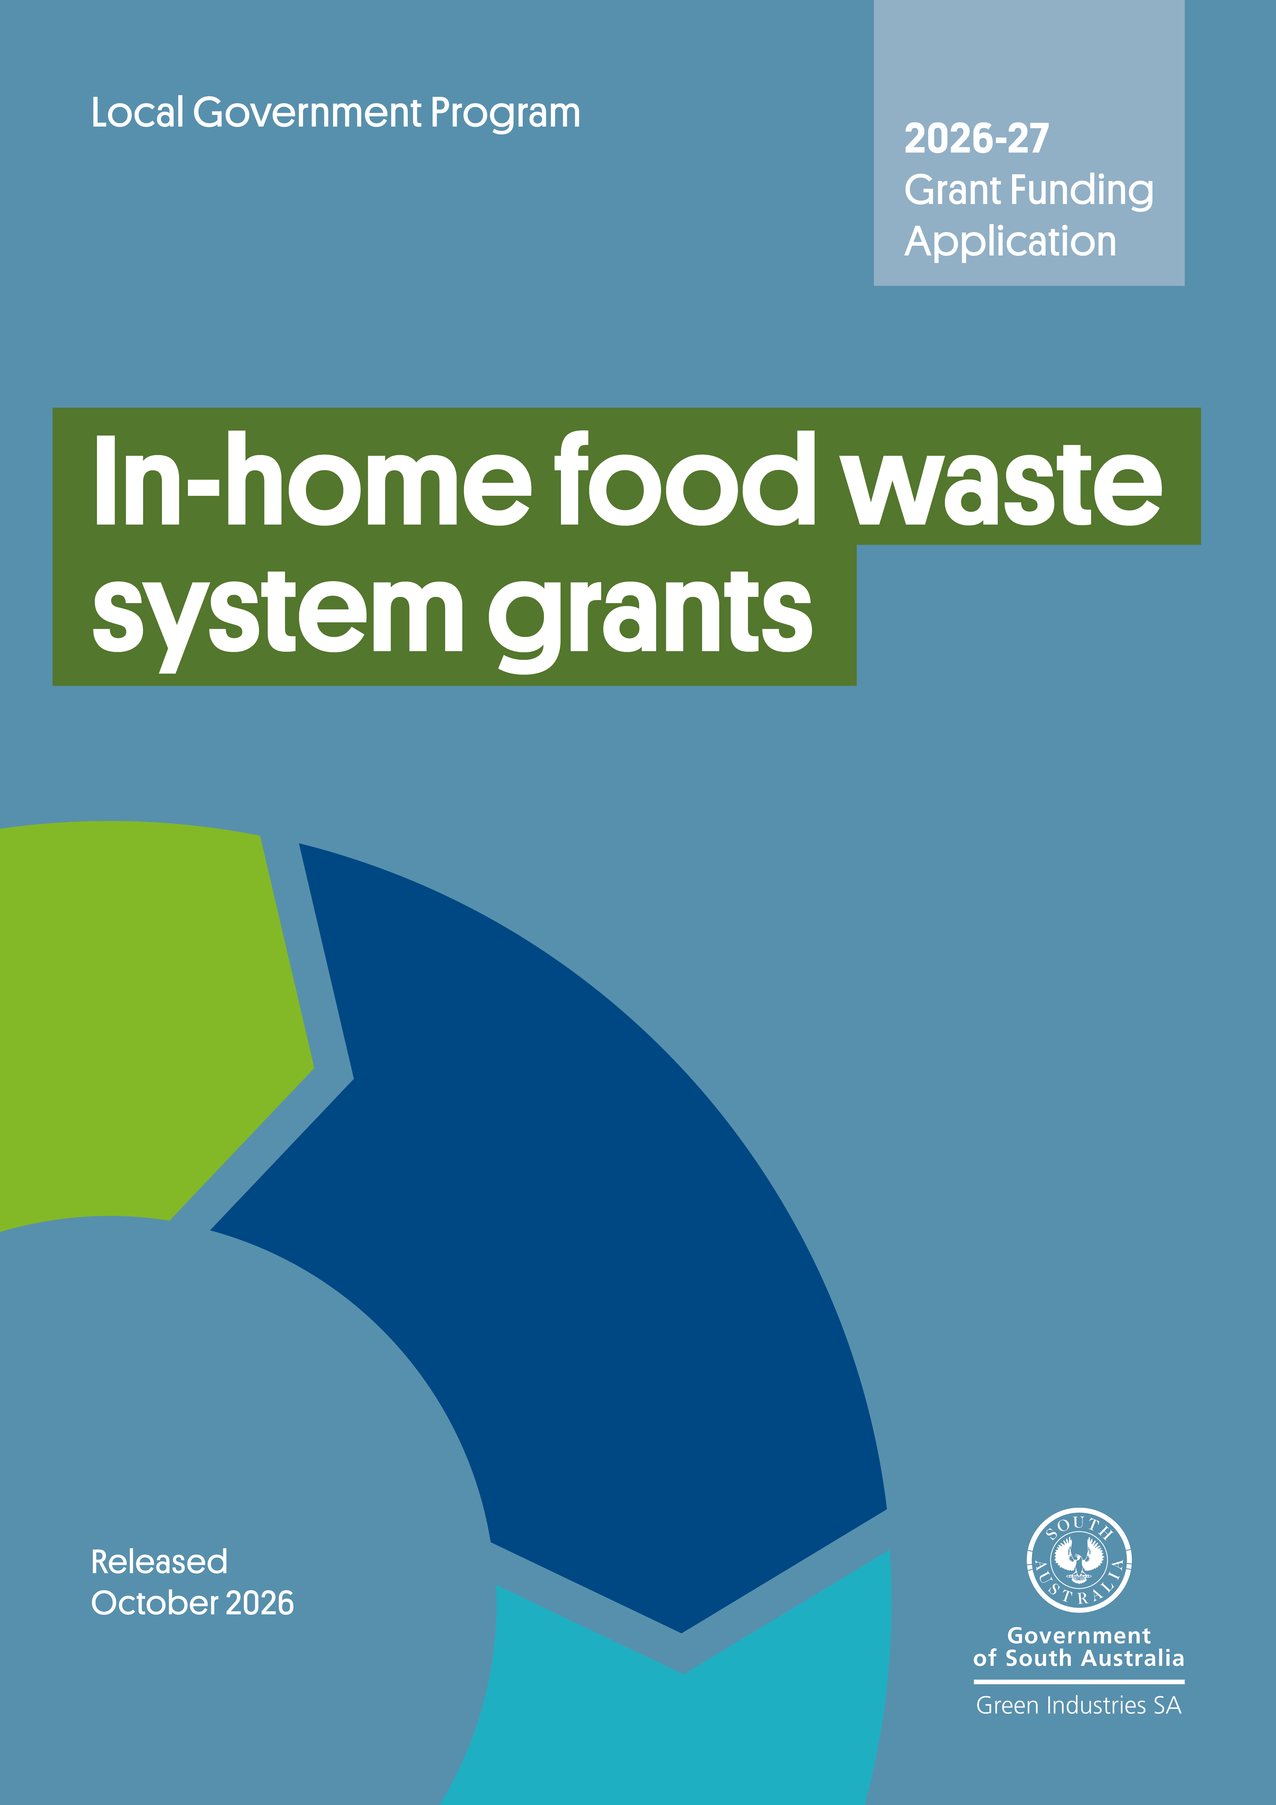

Contents
Program overview 1
Submitting your application 1
Need assistance? 1
Section A: General applicant information 3
Section B: Eligibility criteria checklist 4
Section C: Details of proposed in-home food waste system 5
Section D: Declaration 11

Acknowledgement of Country
Green Industries SA acknowledges and respects the Traditional Custodians whose ancestral lands we live and work upon, and pays respect to their Elders past, present and emerging.
We acknowledge and respect their deep spiritual connections, and the relationship that Aboriginal and Torres Strait Islander people have to Country.
We extend our respect to all Aboriginal and Torres Strait Islander peoples and their nations in South Australia, and across Australia

Program overview
The In-home Food Waste System Grants assist councils to implement effective food waste recycling systems for residents and small businesses that use council-collected kerbside organics bins. By providing food waste (kitchen) caddies, compostable liners and educational materials council can boost effective food waste diversion through council provided kerbside collection services. The type of in-home infrastructure and education materials supported through this program have been demonstrated to improve householder participation and food waste diversion rates.
It recognises that disposing food to landfill represents the loss of a potentially valuable resource that can be circulated back into productive soils, and that when food waste is blended with kerbside green organic material, it improves the quality and nutrient value of the processed compost.
Please refer to the Guidelines and support information on the In-home Food Waste System Grant program webpage when preparing your application.

Submitting your application
Applications will be accepted until 5 pm ACDT, 4 December 2026.
Late applications will not be assessed.
Please email your completed application form, including a signed declaration, with all supporting documents to han.tran@sa.gov.au with the subject line ‘In-home Food Waste System Grants 2026-27 – application – [applicant name]’.
Emails should not exceed 10MB and applications are to be no more than 20 pages including supporting information.

Before completing your application:
- Read the grant funding guidelines in detail. The guidelines have important information regarding eligibility, the application and assessment process, and funding conditions.
- Complete all relevant sections of the application form.
- Attach and clearly number evidence in support of the application.
- Understand that applying does not guarantee funding approval. Your application will be assessed for eligibility and alignment with assessment criteria published in the grant guidelines. Funds are awarded at the discretion of GISA, and in accordance with budget availability for applications that satisfactorily meet all eligibility criteria and pass assessment criteria.

Need assistance?
For further information, or to discuss your application and eligibility, contact Justin Lang at justin.lang@sa.gov.au or on 0419 948 931.
Councils considering the implementation of weekly kerbside organic collections to households and small businesses, or introduction of kerbside organics collection (regional only) should submit an application under the Sustainable Kerbside Services Grants, as a separate (and complimentary application (if applicable).

Section A: General applicant information
A1. Name of organisation
A2. Business registration
Australian Business Number (ABN):
A3. Is your organisation (tick one):
The lead organisation of a consortium or partnership? |  |  |  | The sole applicant?
A4. If you are applying as the lead partner in this application, please give the names of the other organisations in the project and their roles.
A5. Applicant address
Street address:
Suburb: State: Postcode:
Postal address for correspondence (if different from your business address)
Street address:
Suburb: State: Postcode:
Website:
A6. Contact details:
Primary contact details: Person within the applicant organisation who will manage/oversee project delivery.
Full name: |  | Position:
Tel: |  | Mobile:
Email:
Secondary contact details: Person within the applicant organisation who will support project delivery.
Full name: |  | Position:
Tel: |  | Mobile:
Email:

Section B: Eligibility and assessment criteria checklist
Applications that do not meet all of the below criteria will not be assessed further.
To be eligible for funding the applicant must meet all eligibility criteria below | Yes | No
Applicant is a South Australian council or subsidiary under the Local Government Act 1999 | ☐ | ☐
The project requests no more than 50% funding contribution by GISA up to $10 per eligible serviced tenement per grant round (excluding in-kind and initial supply of compostable liners) | ☐ | ☐
Educational materials with GISA-approved branding (e.g. Which Bin) will be included in the food waste system at the time of distribution. | ☐ | ☐
Communication materials with GISA-approved branding (e.g. Which Bin) will be used for engagement activities and the application provides details of the education and communications activities, including frequency and/or proposed timing. | ☐ | ☐
Application indicates the expected diversion potential of the proposed system. | ☐ | ☐
Number of households or serviced tenements for the system rollout is provided, supported by area maps and latest ABS data/rates data. | ☐ | ☐
The project uses high performing systems that have successfully demonstrated food waste diversion outcomes, including ventilated caddies and AS certified compostable liners | ☐ | ☐
The application is complete and includes valid quotes for the purchase of project materials (e.g. kitchen caddies, bags, etc.) | ☐ | ☐
The project has a clear timetable for rollout, and an experienced project manager is assigned to manage project delivery. | ☐ | ☐
Proposed system is congruent with program guidelines and priorities for the program | ☐ | ☐
Details of contractors and processors are clearly listed with appropriate licensing and  evidence that products sold meet Australian Standard 4454-2012 and are or will be supplied  to higher beneficial use end markets | ☐ | ☐
Details of recognised higher-use end markets* are clearly provided and are intended to remain valid for the duration of the proposed project | ☐ | ☐
*organic material is composted to AS 4454 (where applicable) and supplied to beneficial, higher-use end markets in agricultural, viticultural, horticultural and urban amenity settings, to achieve the highest circular economy outcomes

Section C: Project proposal

C.1 Details of proposed in-home food waste system
Details of container manufacturer (supplier)
Name:
Address:
Website:
Container type (please tick) | Ventilated (requiring compostable liner bags) | Non-ventilated
Number of systems to be provided: | [number] households  (round to nearest 100) | [number] commercial premises  (round to nearest 50)
Estimated cost per container: | $ | Capacity: Litres
Was this price sought through a competitive tender process? | Yes, please provide details of tender below | No, please detail selection process to be undertaken below
Details of tender/selection process:
What is council’s current disposal cost/tonne for residual waste? $ per tonne
(please indicate if including or excluding solid waste levy)

What is council’s current processing cost/tonne for organics? $ per tonne

(If the applicant is applying on behalf of multiple partner organisation, please provide the cost/tonne details for each of the partner organisations by adding additional rows)
Estimated landfill diversion outcomes of the proposed system: tonne per annum

C2. Project summary
Funding is sought for (please tick the options below):
- Providing in-home food waste systems to new residents in the area, replace broken or absent caddies.
- In-home food waste collection systems to support implementation of area-wide kerbside food organics collections systems or increased frequency of organics collections
- Expanding provision of in-home food waste systems to all households
Please further detail the project that funding for in-home food waste collection systems is being sought. This should include the method of distributing containers, compostable liner bags and education materials.

Has this application been submitted concurrently with an application for the Sustainable Kerbside Services Grants? Yes No

C3. Proposed budget (itemise all capital expenditure items)
Please include detailed quotes for any goods and services to be procured where applicable, noting quotes must include suppliers’ details including ABN and any GST component.

Expenditure Item | Anticipated order date | Funding sought  (no more than 50% unless liner bags) | Applicant contribution | Total cost
Description | (mm-yyyy) | $ ex GST | $ ex GST | $ ex GST
Containers
Certified compostable liner bags (if required) |  |  | N/A
Education material provided with the container – brochure
Other in-home education material – please specify (e.g. stickers, prompts)
Assembly – please specify (e.g. service club)
Distribution – please specify (e.g. service club)
Other (please specify)
Totals: |  | $ | $ | $
GISA funding as % of total funding:

Other funding source
Any other grants or funding that the applicant, partners, and sub-contractors for this application have or will receive relating to the activities proposed in this project.
Project activities/element | Organisation providing other funding/payment |  | Contact details for organisation | Amount of funding/payment |  | Relationship to this project
 |  |  |  | $
 |  |  |  | $
 |  |  |  | $
Please provide a breakdown of any in-kind contributions
Project element |  | Organisation providing in-kind contribution |  |  | Value of in-kind contribution
 |  |  |  |  | $
 |  |  |  |  | $
 |  | Total value of in-kind contribution |  |  | $
 |  | Total project budget² |  |  | $

C4. Council approval and budget allocations
If your application is successful, y
ou will need to provide details of an appropriate organisational approval (e.g. council resolution) and reports within 3 months of receiving the initial notification regarding this application, or within 3 months of signing of the grant agreement, and before grant funds are released. If already obtained, please attach a copy.
Has council obtained approval to:
- support implementation of area-wide kerbside food organics collections systems or increased frequency of organics collections Yes No
OR
- expand provision of in-home food waste systems, including replacement Yes No

If ‘Yes’, please include details of the approval below and attach a copy of the report as part of the application.

If ‘No’, when is the approval likely to be provided? (please detail below)

C5. Implementation timeline
Action | Estimated date (mm-yyyy)
Order containers
Design of education material
(contact GISA for customised Which Bin or other appropriately branded materials)
Initial communication to residents (e.g. council newsletter)
Printing education materials
Shipping (delivery to central location)
Assembly and distribution of containers to households
Commencement of organics collections or increased collection frequency (if applicable)

C6. Contracts for collection and processing
Name of organics collection contractor:

Collection contractor EPA license number:
Contract in place for collection of organics: Yes No |  | Expiry date:
Name of licenced organics processor and processing site:

Organics processor EPA license number:
Contract in place to accept organics? Yes No |  | Expiry date:
End markets where composted material is sent for high-value beneficial reuse:
Please attach evidence of composted materials being supplied to higher-use end markets (e.g. agriculture, viticulture, etc.). Evidence can include email or other document from the receiving facility or business confirming the material received and its use.
Recycling and reprocessing facilities that are certified to a recognised standard or accreditation (e.g. GECA) will be highly regarded.

C7. Communication and consultation
Has a communications plan been prepared? | Yes, (please include/attach) | No
Please detail what community consultation has/will occur:
Please indicate below what efforts council will be putting into education for the term of the agreement with GISA.
Regular features in council newsletters | Composting workshops
Web-based waste reduction information | Regular ads in local papers
Community education brochure | Social media
Tours of composting facilities | Other (please specify)
Which Bin or other GISA-approved branded resources requested (brochure, rates insert, DL fridge magnet, social media tiles)

C8. Capacity and capability to manage the project
Please explain and demonstrate applicant and project partners/sub-contractors (if applicable) capacity and capability to manage and deliver the project successfully. Please add rows if needed.
Name:
Position:
Role in this project:
Relevant experience/expertise:

Name:
Position:
Role in this project:
Relevant experience/expertise:

C9. Project milestones
Please outline project milestones and key activities (add more rows as required)
 | Milestone and key activities | Start date  (dd/mm/yy) | Completion  (dd/mm/yy)
1 | Milestone title:  Key tasks/activities:
2 | Milestone title:  Key tasks/activities:
3 | Milestone title:  Key tasks/activities:

C10. Monitoring and evaluation
Please list project key performance indicators (KPIs), how they will be measured (what data will be captured/what’s the unit of measurement) and a target (goal) for each in the table below.

 | KPI | How it will be measured | Target
1
2
3

C11 Project risk management
Please identify and describe the key risks associated with the project, along with the proposed mitigation measures. For guidance on likelihood, consequences, and risk ratings, refer to Guidance on Risk Assessment in the Application Support Guide. (Add more rows as required)
 | Risk short name | Risk description | Likelihood | Consequences | Inherit risk rating | Control/mitigation strategy | Residual likelihood | Residual consequences | Residual risk rating
1
2
3
4
5
6

Section D: Declaration

Application checklist

☐ | Completed all relevant sections of the application form in full
☐ | Included detailed quotes for any goods and services to be procured, noting quotes must include suppliers’ details including ABN and any GST component
☐ | Attached all supporting documents, such as council approval or resolution documents, if applicable
☐ | Included identification of the main risks associated with the project and the proposed mitigation measures (demonstrating appropriate project risk management)
☐ | Signed the declaration (ensuring it is signed by an authorised officer)

Declaration
- I have read and understood the In-home Food Waste System Grant program guidelines and obtained clarification where needed.
- I declare that the information provided in this application including attachments is to the best of my knowledge true and correct and discloses all required and relevant details. I understand that if information supplied as part of the application is false or misleading in a material particular, the application will not be considered OR, if the grant is made and it is discovered that information supplied was false or misleading in a material particular, the grant will be revoked and funds must be repaid. An assessment regarding possible fraud will also be undertaken and appropriate legal action initiated if warranted.
- I declare that I/we have complied with federal and state laws, regulations, and the Environment Protection Authority licences (if any).
- I authorise Green Industries SA to seek any additional relevant information required to process this application, and I/we hereby request and authorise any parties to supply such information as requested.
- I understand that if the project is approved for funding, information of a non-sensitive and non-confidential nature about the project may be publicised by Green Industries SA or provided as required or permitted by law.
- I understand that submission of this application does not guarantee funding approval and that all applications are assessed by Green Industries SA against the assessment criteria, with funds allocated in accordance with assessment results and budget availability.
- If I accept an offer of funding, then I accept (jointly and severally in the case of a group application) responsibility for administering grant funds and liability in the event grant funds are to be repaid.
This declaration must be signed by an appropriately authorised representative of the applicant organisation, such as the Chief Executive, Executive Officer, Chairperson, or equivalent.
The signatory must hold sufficient authorisation to ensure the applicant complies with the points listed above and is able to approve/enter into an agreement with Green Industries SA should the application be successful.

Signed
Name
Position
Date

