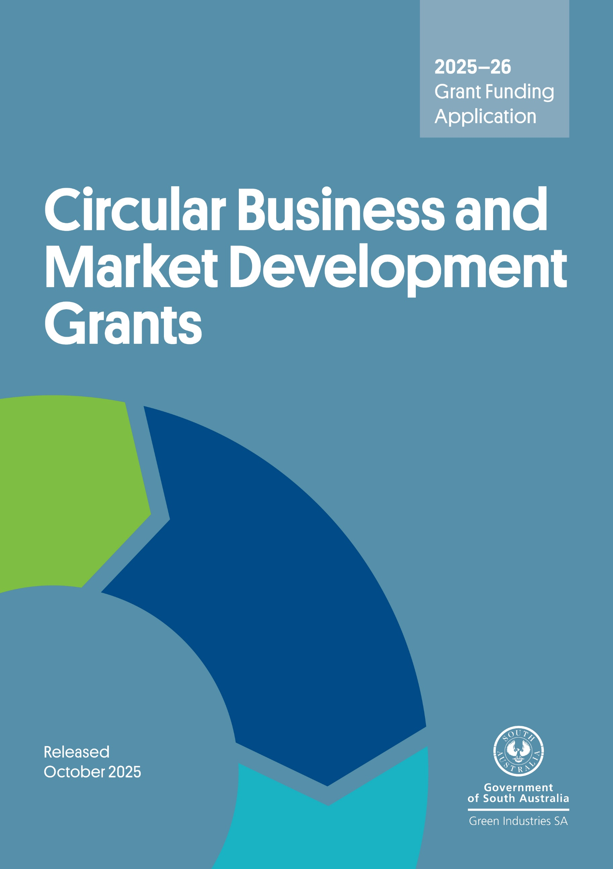

Program overview

The Circular Business and Market Development Grant program aims to assist businesses, local authorities, industry groups, not-for-profit organisations, social enterprises and research institutions to accelerate the transition to a more circular economy via supporting adoption of, upscaling, increased market confidence and acceptance of innovative and commercial circular economy business models, solutions and practices as well as refurbished/repaired or recycled content products.

Submitting your application
Applications will be accepted until 5 pm ACDT, Friday 28 November 2025. No late applications will be accepted without prior written extension granted by Green Industries SA.
Please email your completed application form, with a signed declaration, including all supporting documents to serena.yang@sa.gov.au with subject line Circular Business and Market Development Grant – application. Emails should not exceed 10MB.

Checklist
Before submitting your application, please check you have:
- read the Circular Business and Market Development Grant Guidelines 2025–26 in detail
- completed the application form in full
- signed the declaration
- attached copies of a Certificate of Currency for insurance (as required) and all supporting documents.
Need assistance?

Email serena.yang@sa.gov.au for more information and/or to check your eligibility.
Section A: General Information
A1. Name of organisation (or the lead organisation administering the project if the proposal is submitted by a partnership)
Registered business name:
Trading name (if any):
A2. Business registrations
Australian Business Number (ABN):
Australian Company Number (ACN):
A3. Is your organisation registered for GST?
☐ Yes ☐ No
A4. Business address
Street address:
Suburb: State: Postcode:
Your postal address, if different from your business address
Street address:
Suburb: State: Postcode:
A5. What is the legal status of your organisation? (Select only ONE box)
☐ Proprietary limited company ☐ Incorporated association
☐ Company limited by guarantee ☐ Local government
☐ Sole trader ☐ Other (please detail):
A6. Primary contact details
Name: | Position:
Email: | Mobile:
A7. Name of partner organisation and contractors for this application (if any)
Partner 1
Name:
Address:
Partner 2
Name:
Address:
Partner 3
Name:
Address:
A8. Insurance (please attach copies of Certificates of Currency as required)
Public Liability (to the value of at least $1 million per claim for the duration of the proposed project)
YES ☐ NO ☐ PENDING ☐
Professional Indemnity (to the value of at least $1 million per claim for the duration of the proposed project, delete if not relevant)
YES ☐ NO ☐ PENDING ☐

A9. Applicant background
How long has your organisation been in operation?
How many FTEs does the organisation currently employ?
How many FTEs are based in South Australia?
Annual turnover for the last 2 financial years? |  | 2023–24: $
 |  | 2024–25: $
Briefly describe the core business of your organisation (for example, your product or service, market segment and major customers, and so on):

Section B: Eligibility Criteria Checklist
To be eligible for funding the applicant must meet all eligibility criteria below
 | Yes | No
B1. Will the applicant be implementing the project whereby the primary focus and benefits are for, and remain within, South Australia? | ☐ | ☐
B2. Is the applicant solvent and able to enter into a legally binding funding agreement with the South Australian Government? | ☐ | ☐
B3. Does the applicant have a current Australian Business Number and registered for GST? | ☐ | ☐
B4. Does the applicant comply with all federal and state laws, regulations and any applicable Environment Protection Authority (EPA) requirements? | ☐ | ☐
Please answer the following EPA information:
- Will the proposed project involve activities that would require an EPA Licence?  EPA-licensable activities are listed in Section 4 Part B of EPA South Australia l New Licence Application l August 2025 and in further detail in Schedule 1 Part A of the Environment Protection Act 1993.  If unsure, please state here: __________________________________________ | ☐ | ☐
- Confirm if the activities would involve the receipt, storage, treatment, processing of:
- >100 tonnes or >100 kiloliters of waste per year | ☐ | ☐
- >5 tonnes of tyres or tyre waste (500 passenger tyres) | ☐ | ☐
- >500 waste batteries per year | ☐ | ☐
- Will the activities involve waste disposal | ☐ | ☐
- Do you already have an EPA licence? | ☐ | ☐
- Will the proposed project for an additional activity on an existing licence?  If yes, state your EPA Licence No: _______________________ | ☐ | ☐
- Address of premises where activity will take place:
_______________________________________________________________________
- Does the applicant(s) own the site?  If no, from whom are the premises leased or rented?  _______________________________________________________________________ | ☐ | ☐
- Has full Development Approval or other approval been granted to undertake the activity(ies) at the site?  If not applicable, please state here: __________________________________________ | ☐ | ☐
- Do you have any other approvals, indentures, licences for the premises?  If not applicable, please state here: __________________________________________ | ☐ | ☐
- Has the applicant or a director ever contravened the Environment Protection Act 1993 or has held an environmental authorisation or other authority that has been cancelled or suspended under the Act or any other environmental legislation in Australia?  If yes, please include full details of the law contravened and the person(s) who committed the contravention (e.g. who, which Act or regulation, date of contravention, any penalty imposed, and so on)  Additional information:  __________________________________________________________________________  __________________________________________________________________________ | ☐ | ☐
B5. Has the applicant been operating for a minimum of 2 years?* | ☐ | ☐
B6. Does the applicant have operations in South Australian for the duration of the proposed project (e.g. have an office or staff based in South Australia)? | ☐ | ☐
*Applications from applicants who have been operating for less than 2 years may be considered on a case-by-case basis if sufficient justification is provided.
To be eligible for funding the project must meet all eligibility criteria below
 | Yes | No
B7. Does the proposed project meet and contribute to the objectives and aims of:  - South Australia’s Waste Strategy 2020-2025  - the Circular Business and Market Development Grant Program 2025–26. | ☐  ☐ | ☐  ☐
B8. Does the proposed project demonstrate the need for government funding for at least one of the below 3 focus areas?  - Identify, design, apply and/or scale-up innovative circular economy business models, solutions and practices  - Validate and improve the transparency, quality and performance of local refurbished/repaired or recycled-content products  - Develop new markets or expand existing markets for circular economy business models, solutions and practices or refurbished/repaired or recycled-content products | ☐  ☐  ☐ | ☐  ☐  ☐
B9. Does the project target the identified waste materials?  The identified priority waste materials are plastics, textiles, food waste and organics, e-waste, batteries (excluding used lead acid batteries), paper and cardboard, glass, scrap metals, tyres, and emerging or problematic waste materials (such as solar PV panels, wind turbine blades and CCA treated timber). Other materials may be also considered.  Please specify the targeted waste materials: _________________________________________ | ☐ | ☐
B10. Will the project outcomes provide a measurable economic, environmental, or social benefit to South Australia? | ☐ | ☐
B11. Will the project be focused on South Australia with a significant component of the project activities (i.e. more than 50%) to being undertaken in South Australia? | ☐ | ☐
B12. Does the project have a clear implementation timeframe and milestones? | ☐ | ☐
B13. Does the project involve new activities which have not been commenced previously? | ☐ | ☐

Applications that do not meet the above criteria will not be assessed further.

Section C: Project proposal
C1. Project title
C2. Project timeframe
Proposed start date: |  | Expected completion date:
C3. Project milestones
Outline project milestones and key activities – add rows if required.
Please make allowances for the grant assessment process when planning for start dates.
 | Milestone and key activities | Start date  (dd/mm/yy) | Completion date  (dd/mm/yy)
1. | Milestone title:  Key tasks/activities:
2. | Milestone title:  Key tasks/activities:
3. | Milestone title:  Key tasks/activities:
C4. Project summary (please give a short description of the project, maximum 100 words)
This summary may be used by Green Industries SA for promotional purposes.
C5. Project description (please provide a detailed description of your project)
Please explain why the project and the government funding support are needed, project objectives/outcomes, how innovative the project is, how the project will address one or more identified market or systemic gaps or barriers and how market opportunities for new circular economy business models and practices or reuse, repair/refurbishing and use of recycled materials/products would be improved, sustainability, economic and local benefits arising from the project.

Response to assessment criteria

Weighted criteria – projects will be scored out of 100 points for each individual weighted criterion. To be eligible for funding, a project must score at least 50 points.

C6. Assessment criterion: Innovation and commercial solutions
Explain the degree of innovation in addressing market challenges or barriers and providing commercial solutions, why the innovation is better than other alternatives (if any) and how innovative the project is in leading the market.

C7. Assessment criterion: Market opportunity
Explain the target customer or market segments, and how the project will address at least one identified market or systemic gap or barrier. Explain the extent to which the project will lead to an increase in the value, size and/or diversity of markets (local, national, or international).

C8. Assessment criterion: Environmental, social and economic benefits
Explain the extent to which the project will benefit South Australia’s economy, environment, and society, such as increased local employment, increased circularity outcomes via waste avoidance and reduction, reuse/repairing/refurbishing, use of recycled content products, reduction in landfill disposal, increased duration of product/materials lifecycles and value, and greenhouse gas emissions reduction.
C9. Assessment criterion: Value for money
Explain the need for government funding support, the extent that grant funding is leveraged with other funding, comparison of project costs/inputs to expected project outcomes (environmental, economic and social) and alignment to program objectives and government strategic priorities.
Provide a project budget using the template below with all costs reported as GST exclusive. Separate sections are provided below for the private sector business applicants and non-private sector applicants respectively. Please choose the applicable section to fill in details.
Note that private sector business applicants should contribute at least 50% of eligible project costs, excluding in-kind contribution.

Preliminary budget (exclusive of GST) – For private sector business applicants
Expenditure item |  | Total project cost | Total GISA funds sought |  | Applicant contribution |  |  |  | Other funding sources
 |  | Cash | Cash |  | Cash |  |  |  | Cash
 |  | $ | $ |  | $ |  |  |  | $
 |  | $ | $ |  | $ |  |  |  | $
 |  | $ | $ |  | $ |  |  |  | $
 |  | $ | $ |  | $ |  |  |  | $
 |  | $ | $ |  | $ |  |  |  | $
 |  | $ | $ |  | $ |  |  |  | $
 |  | $ | $ |  | $ |  |  |  | $
 |  | $ | $ |  | $ |  |  |  | $
 |  | $ | $ |  | $ |  |  |  | $
 |  | $ | $ |  | $ |  |  |  | $
 |  | $ | $ |  | $ |  |  |  | $
Total |  | $ | $ |  | $ |  |  |  | $
% of total funding
Preliminary budget (exclusive of GST) – For non-private sector applicants
Expenditure item |  | Total project cost | Total GISA funds | Applicant contribution (cash & in-kind) |  |  |  | Other funding sources (cash & in-kind)
 |  | Cash & in-kind | Cash | Cash |  |  | In-kind | cash |  |  | In-kind
 |  | $ | $ | $ |  |  | $ | $ |  |  | $
 |  | $ | $ | $ |  |  | $ | $ |  |  | $
 |  | $ | $ | $ |  |  | $ | $ |  |  | $
 |  | $ | $ | $ |  |  | $ | $ |  |  | $
 |  | $ | $ | $ |  |  | $ | $ |  |  | $
 |  | $ | $ | $ |  |  | $ | $ |  |  | $
 |  | $ | $ | $ |  |  | $ | $ |  |  | $
 |  | $ | $ | $ |  |  | $ | $ |  |  | $
 |  | $ | $ | $ |  |  | $ | $ |  |  | $
 |  | $ | $ | $ |  |  | $ | $ |  |  | $
 |  | $ | $ | $ |  |  | $ | $ |  |  | $
Total |  | $ | $ | $ |  |  | $ | $ |  |  | $
% of total funding |  | 100%
Other funding source
Any other grants or funding that the applicant, partners and sub-contractors for this application have or will receive relating to the activities proposed in this project.
Project activities | Organisation providing other funding/payment |  | Contact details for organisation |  |  | Amount of funding/payment |  |  |  | Relationship to this project
 |  |  |  |  |  | $
 |  |  |  |  |  | $
 |  |  |  |  |  | $
Provide a breakdown of any in-kind contributions
Project activities | Organisation providing in-kind contribution | Value of in-kind contribution
 |  | $
 |  | $
 | Total value of in-kind contribution | $
 | Total project budget | $

Non-weighted criteria – must be assessed as sufficient for the application to be regarded as eligible for potential grant funding.
C10. Assessment criterion: A clear and credible description of the proposed project activities
Provide a clear description of each major task to be performed. Applications must demonstrate a clear link between project activities/tasks and the achievement of project goals/outcomes that align with the objectives of the Circular Business and Market Development Grant program.

Project task/activity | Description |  | Deliverables |  | Start date | End date
C11. Assessment criterion: Capacity and capability to manage the project
Explain and demonstrate applicant and project partners/sub-contractor’s (if applicable) capacity and capability to manage and deliver the project successfully.
- Key people involved in the project
Name: |  |  |  | Position
Role in this project and relevant experience/expertise

Name: |  |  |  | Position
Role in this project and relevant experience/expertise

- Information on sub-contractors and/or product testing organisations, if any
Role in this project and relevant experience/expertise, details of accreditation and the appropriate testing guidelines for product testing organisation

(c) Describe the capacity of your organisation to implement the project successfully such as financial viability, any supporting partnerships and an understanding and compliance with the relevant regulatory requirements. Changes to commodity stock prices should be considered if relevant to the project.
C12 (a). Assessment criterion: Project measurement and evaluation
Describe how the project will be measured and evaluated, including proposed key performance indicators (KPIs) and data collection
List KPIs, e.g. reduction in waste generated, increased circularity, improved product performance specifications, increased market demand, diversified product range, environmental, economic and social benefits
Explain how you will establish a baseline for each KPI, data to be used, and how you will obtain it.

Project evaluation
Methodology and data to be used for evaluation and how you will obtain it.

C12 (b) Project risk management
Identify and describe the key risks associated with the project, along with the proposed mitigation measures. For guidance on likelihood, consequences, and risk ratings, refer to Appendix A: Guidance on Risk Assessment.
 | Risk short name | Risk description | Likelihood | Consequences | Inherit risk rating | Control/mitigation strategy | Residual likelihood | Residual consequences | Residual risk rating
1
2
3
4
5
6

Section D: Declaration

Declaration
- I have read and understood the guidelines and obtained clarification where needed.
- I declare that the information provided in this application including attachments is true and correct and discloses all required and relevant details. I/we understand that if information supplied as part of the application is false or misleading in a material particular, the application will not be considered OR, if the grant is made and it is discovered that information supplied was false or misleading in a material particular, the grant will be revoked and funds, plus interest, must be repaid. An assessment regarding possible fraud will also be undertaken and appropriate legal action initiated if warranted.
- I declare that I/we have complied with federal and state laws, regulations and the Environment Protection Authority licences (if any).
- I authorise Green Industries SA to seek any additional relevant information required to process this application, and I/we hereby request and authorise any parties to supply such information as requested.
- I understand that if the project is approved for funding, information of a non-sensitive and non-confidential nature about the project may be publicised by Green Industries SA or provided as required or permitted by law.
- If the project is approved for funding, I will obtain all necessary and appropriate clearances from the relevant Commonwealth, state or local governments before executing the grant agreement and undertake to manage the proposed project in accordance with relevant laws and regulations.
- I understand that submission of this application does not guarantee funding approval and that all applications are assessed by Green Industries SA against the assessment criteria, with funds allocated in accordance with assessment results and budget availability.
- If I accept an offer of funding then I accept (jointly and severally in the case of a group application) responsibility for administering grant funds and liability in the event grant funds are to be repaid.
This declaration must be signed by an appropriately authorised representative of the applicant organisation, such as the Chief Executive, Executive Officer, Chairperson, or equivalent.
The signatory must hold sufficient authorisation to ensure the applicant complies with the points listed above and is able to approve/enter into an agreement with Green Industries SA valued up to $100,000 (exc. GST) should the application be successful.
Signed
Name
Position
Date

Appendix A – Guidance on risk assessment
How to undertake a risk assessment for a project:
1. Identify the risks: Using the table you are required to complete in assessment criteria C12(b) Project risk assessment list potential risks to the project (such as delays, budget overruns, safety issues).
2. Assess inherent risk (before controls): Using table 1 (likelihood) and table 2 (consequence) below, determine the inherent risk rating for each risk. Then apply table 3 (risk matrix) to assign a risk level (such as low, medium, significant, high, extreme).
3. Identify and apply controls: Outline practical control measures/mitigation strategies to reduce either the likelihood or consequence of the risk and add them to assessment criteria C12(b) Project risk assessment.
4. Assess residual risk (after controls): Reassess the likelihood and consequence after controls are applied, again using tables 1 to 3, to determine the residual risk rating you are required to add to assessment criteria C12(b) Project risk assessment.
Table 1: Qualitative measures of likelihood
Likelihood | Level | Description | Explanation – Projects/ business case | FREQUENCY (Description) | Explanation – operations
Almost certain | A | Over 99% probability, happens often (once or more a week), could occur within days to weeks | Could be expected to occur more than once during the study or project delivery | Event is expected to occur in most circumstances | It is expected to occur again, immediately or within a short period – likely to occur most weeks or months.
Likely | B | 50% probability, could easily happen (once or more a month), could occur within weeks or months | Could easily be incurred and has generally occurred in similar studies or projects. | Event could occur in most circumstances | Will probably occur in most circumstances – several times a year.
Possible | C | 10% probability, can happen, has occurred before (once or more a year), could occur after several years | Incurred in a minority of similar studies or projects | Event could occur at some time | Could be incurred within a 1-to-2-year period.
Unlikely | D | 1% probability, has not happened yet, but could (once or more every 5 years), could occur after several years | Known to happen, but only rarely. | Event could occur in circumstances | Could be incurred in a 2-to-5-year time frame.
Rare | E | <1% probability, conceivable but only in extreme circumstances (once or more every 10 years), exceptionally unlikely, even in the long term | Has not occurred in similar studies or projects. Conceivable but in extreme circumstances. | Event may only occur in exceptional circumstances | May occur in exceptional circumstances. Could be incurred in a 5-to-30-year timeframe.

Table 2: Qualitative Measures of Consequence
Impact area | Impact scale
Impact area | 1 – Minimal | 2 – Minor | 3 – Moderate | 4 – Major | 5 – Severe
Financial loss | Minimal financial loss (<$2K) | Minor financial loss ($2K to $5K) | Moderate financial loss ($50K to $100K) | Major financial loss ($100K to $1M) | Catastrophic financial loss ($1M+)
Work health and safety | No injuries or no injury requiring treatment | First aid treatment | Minor injuries requiring medical attention | Moderate injuries | Major or severe injuries including fatalities
Effect on public image | No adverse effect | Minor adverse effect: kept in-house, no media interest | Local media coverage, moderate adverse effect | State media coverage | International and/or national media coverage, leads to changes at Board or Executive level.
Level of community concern | No community interest | Limited community interest | One or two community complaints | Significant community interest | Community outrage
Impact on stakeholder relationships | Negligible adverse impact | Disadvantage for stakeholders (days-weeks) | Significant disadvantage to multiple stakeholders (weeks) | Multiple stakeholders severely disadvantaged (weeks) | Majority of stakeholders severely disadvantaged (months)
Impact on objectives | Limited impact on objectives | Impedes one or more objectives or causes inefficiencies in key processes | impedes achievement of important objectives/causes extensive inefficiencies in key processes | Serious process breakdown that substantially impedes the achievement of core objectives | Serious process breakdown that prevents the achievement of mission critical objectives.

Table 3: Risk matrix
 |  | CONSEQUENCE
Column2 | Column1 | Minimal | Minor | Moderate | Major | Severe
LIKELIHOOD |  | 1 | 2 | 3 | 4 | 5
Almost Certain | E | Medium | Significant | High | Extreme | Extreme
Likely | D | Medium | Medium | Significant | High | Extreme
Possible | C | Low | Medium | Significant | High | High
Unlikely | B | Low | Low | Medium | Significant | High
Rare | A | Low | Low | Medium | Significant | Significant

Total project budget is the total cost of the project plus in-kind contributions

