2022-23 GREEN INDUSTRIES SA
WOMEN IN CIRCULAR ECONOMY LEADERSHIP SCHOLARSHIP
APPLICATION GUIDELINES AND NOMINATION FORM

Aim of the Scholarship
The aim of this Scholarship is to provide an opportunity for a South Australian woman who is an emerging or established leader working in the area of the circular economy to pursue an investigative project of a kind that is not readily available in South Australia.

The research should be action-orientated, with a view to applying the research findings to a project which will benefit a business, industry or government organisation in South Australia.

Preference will be given to projects which clearly align with Green Industries SA’s strategic priorities set out in the draft Green Industries SA Strategic Plan 2021-25:

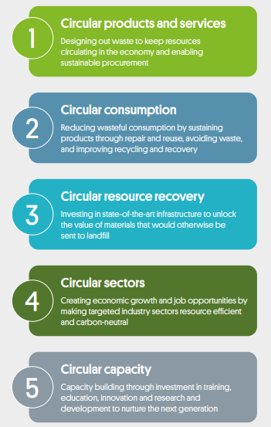

No prescribed qualifications are required. Merit of the proposed project is a key factor and a desire to share the project's findings with the relevant South Australian industry and stakeholders.

Eligibility
To be eligible to apply for a Scholarship you must:
- be an Australian Citizen or a Permanent Resident over the age of 18
- live and work in South Australia
- have experience in and commitment to the circular economy and not be enrolled in tertiary studies directly related to the topic of your proposed project
- have a detailed project plan outlining research methodolgies and expected research outputs and outcomes
- be willing to disseminate the results of your findings.
Note eligibility has been broadened to include women employed by the South Australian Government in addition to women employed in private sectors, research institutes or non-for-profit organisations.

Assessment criteria
Every application for an Award will be assessed as follows:
Project
- The need for this project in South Australia or at a national level
- The benefits of the project to South Australia or at a national level
- The itinerary and places selected to undertake the project
- The achievability of the project.
The upper limit of the Scholarship is $5,000. The nomination form must include a breakdown of the estimated costs of the project proposal e.g. travel, accommodation and/or conference costs etc.
Applicants should also confirm if matched funding will be provided by their employer (matched funding is optional).
Applicant
- Ability to maximise the opportunity of the Scholarship (current standing and experience in the field, skills and/or expertise)
- Ability and commitment to make a difference (ongoing involvement in the field, leadership qualities, a strategic approach, networks)
- Ability and commitment to disseminate findings
- Leadership (e.g. overcoming adversity with determination and creative problem solving, championing the skills of relationship building and negotiation in business, mentoring others to succeed, giving back to the community).
Selection process
A judging panel will consider all nominations for the Scholarship. Based on the initial assessment applicants may be contacted for further information. The panel may elect not to select a recipient of the Scholarship if there is no application of sufficient merit. The decision of the panel is final and no appeals will be accepted.

Scholarship presentation
The Scholarship will be presented to the winner at an event to be confirmed in May/June 2023.
Mentoring
In addition to the cash contribution, emerging leaders will be offered an opportunity for mentoring by experienced women executive leaders who would provide mentoring feedback to Green Industries SA for future improvement.
Conditions of Scholarship
Funds are to be used for travel, accommodation and conference attendance and other costs directly related to the research project and arranged by the successful nominee.
The Scholarship is subject to the successful nominee agreeing to be bound by the conditions laid down in a letter of acceptance document signed between Green Industries SA and the nominee.

NOMINATION FORM

Personal details
Application enquiries

Serena Yang
Manager, Policy and Evaluation
Green Industries SA
Tel. 8204 2051
E: serena.yang@sa.gov.au

Please email your application to serena.yang@sa.gov.au by close of business 17 March 2023.

For a valid entry, all questions must be answered

For a valid entry, all questions must be answered.

Name: | Position:
Organisation:

Tel: | Mobile:
Contact email:

Address:

Date of birth:

Project

Project aim and ‘elevator pitch’
State the purpose or goal of your project. What is the relevance to Green Industries SA’s strategic priorities?

Project description
Describe your project in clear, simple terms that will make it easy to comprehend. Please be specific as possible and provide the estimated cost.
Explain project methodologies/approaches, including a brief description of the activities to be undertaken and the associated estimated cost, such as interviews, site visits, observation or conference attendance etc.
Avoid high risk countries listed at www.smarttraveller.com.au including coronavirus travel bans issued by the Australian Government as travel will not be approved to these countries.

Reasons for application

Experience
List your experience and knowledge in the field of the project. What experience do you have to undertake the project?
Attach your CV and provide a link to your LinkedIn profile page.

New knowledge and influencing change
What new knowledge do you hope to gain? How will you influence positive change and where? Aside from the Scholarship research report how will you disseminate this to Green Industries SA and relevant industry stakeholders and wider community?

Community/industry benefits and circular economy relevance
How will your project benefit South Australia? How relevant is it to the circular economy? Are there broader benefits? Include measurable outcomes and Key Performance Indicators (quantitative and qualitative).

About your leadership

Achievement
Working in the area of the circular economy what has been your proudest achievement in the last five years, and why? What did you learn along the way?

Challenge
Working in the area of the circular economy what has been the greatest test of your leadership and how did you overcome it?

References

Please attach a written reference from your direct manager, Chief Executive Officer, Chairman or Board member who can comment on your professional achievements and personal qualities and provide an opinion regarding:

- the merit of the proposed project
- why the proposed project is necessary
- how the applicant and how South Australia would benefit from the proposed project
- confirming that matched funding will be provided to support the application (optional).

Please include contact details (telephone numbers and email) of your referee.

