2022-23
GREEN INDUSTRIES SA CIRCULAR ECONOMY STUDENT AWARD
APPLICATION GUIDELINES AND NOMINATION FORM

Aim of the Award
The Green Industries SA Circular Economy Student Award supports circular capacity building in the State and offers the opportunity to recognise the innovative thinking and research in the area of the circular economy for South Australian University Honours and Postgraduate students which are able to manifest into realistic solutions for accelerating South Australia’s transition to a circular economy.

The Award will be judged on students’ completed research or thesis within the past 12 months which must be original and address challenges in accelerating adoption of circular economy business models and practices.

Green Industries SA is leading the state’s transition to a circular economy. Green Industries SA Strategic Plan 2021-25 has identified the following strategic priorities focusing on:

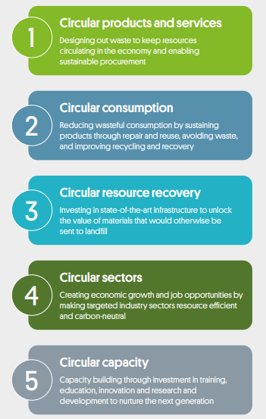

Eligibility
To be eligible to apply for the Green Industries SA Circular Economy Student Award you must:
- have successfully completed a Honours or Postgraduate program with one of the South Australian based universities within the past 12 months, including:
  - University of Adelaide
  - Flinders University
  - University of South Australia
- be willing to promote the results of your research with Green Industries SA.

Assessment Criteria
Every application for the Award will be assessed as follows:
Research work
- Ability to translate the research to realistic and timely solutions in supporting acceleration of circular economy transition or providing circular solutions to present challenges
- Degree of innovation in addressing complex challenges or barriers and providing solutions
- The potential to have real impacts of the research to South Australia or at a national or global level, including economic, environmental and social impacts
- Alignment with Green Industries SA’s strategic priorities.
Selection Process
A Selection Panel will consider all applications for the Award. External expert advice may be sought to assist with panel selection. Based on the initial assessment applicants may be contacted for further information. A short-list of candidates may be invited to present their research to the Selection Panel.
The panel may elect not to select a recipient of the Award if there is no application of sufficient merits. The decision of the panel is final and no appeals will be accepted.
The Prize and Certification

Multiple Awards with a prize of $500 each and a Certificate will be provided. The Award will be paid by Green Industries SA directly to the Australian bank account provided by the winners.

Unclaimed Prize

If Green Industries SA is unable to contact the winner to claim the Award within six weeks of the announcement of the winner, the winner will forfeit the Award in its entirety and it may be awarded to the next runner up in the program.

Timeline:

Opening date for applications: November each year
Closing date for applications: March each year
Selection: April each year
Winner notification: April/May each year
Award presentation: May/June each year
Notification
The winners of the Award will be notified by email and their name and extract of their winning research work will be published on Green Industries SA website.
Award presentation

The Award and a Certificate will be presented to the winner at an event to be confirmed, generally in May or June each year.

APPLICATION FORM

Application enquiries

Serena Yang
Manager, Policy and Evaluation
Green Industries SA
Tel. 8204 2051
E: serena.yang@sa.gov.au

Please email your application to serena.yang@sa.gov.au by close of business 17 March 2023.

For a valid entry, all questions must be answered and supporting evidence be provided.

Student Details

Name: | University:
Discipline/School: | Mobile:
Contact email: | Address:
When did you complete your university honours or postgraduate program?

Research work
Title of your research work
Research aim, outcomes and ‘elevator pitch’
Briefly state the purpose and outcomes of your research. What is the relevance to Circular Economy?

Research description
Detailed description of your research in clear, simple terms that will make it easy to comprehend

Applicability
Please explain: ability to translate the research to realistic and timely solutions in supporting acceleration of circular economy transition or providing circular solutions to present challenges
Please identify: the target customer/market segments and potential market sizing (local, national or international)

Innovation
Please explain: degree of innovation in addressing complex challenges or barriers and providing solutions. Why is the innovation better than other alterantives that already exist in the local and global markets to solve the same problem or meet the same need?
Please include: a high level analysis of the innovation Desirability (validation from the market via interviews or surveys etc), Viability (pricing, costs and potential revenues) and Feasibility (resources and capabilities in SA / Australia for the implementation of this innovation).

Impacts
Please explain: the potential to have real impacts of the research to South Australia or at a national or global level, including economic, environmental and social impacts, and associated Key Performance Indicators such as tonnes of emission reduction, waste diversion, material reused, repurposed or recycled.

Alignment
Please explain: alignment with Green Industries SA’s strategic priorities

Supporting Evidence:

Please include supporting evidence with your application, such as:
- Reference from your supervisor
- Publication of the work if published

NOTE that a full copy of your research may be required for short-listed candidates.

