LOCAL GOVERNMENT PROGRAM

KERBSIDE PERFORMANCE
(FOOD WASTE) INCENTIVES

GUIDELINES

February 2021

Contents

Submitting your application 3
About Green Industries SA 4
South Australia’s Waste Strategy 4
South Australia’s Food Waste Strategy 4
Program overview 5
What do councils need to consider? 5
Container selection 5
Lined containers 6
Financial incentives to recycle food organics 7
Performance-based reporting, audits and financial support 7
Measuring and reporting performance - audits 8
Which Bin branded education and information 8
Kerbside collection or backyard composting 11
What is the incentive offer? 11
What are the conditions attached to the offer? 11
Other conditions 12
What is a ‘serviced tenement’? 12
Contractual arrangements 13
Privacy and commercial-in-confidence considerations 13
Application of grant monies 13
Frequently Asked Questions 13
Assessment process 14
Funding agreement 14
Frequently Asked Questions ……………………………………………………………………16

Submitting your application
All applications should be submitted on the application form attached to these Guidelines and received by Green Industries SA by 5pm, Friday 12 March 2021. All application forms must be submitted with a signed declaration, and be no more than 20 pages (including attachments) and no more than 8MB, in one of the following options:
- Email
Electronically (Microsoft Word file) and supporting information scanned and emailed to justin.lang@sa.gov.au with ‘Kerbside Performance Incentives’ in the subject heading

- Australia Post
Kerbside Performance Incentives
Green Industries SA
GPO Box 1047
Adelaide SA 5001

Further information
Contact Justin Lang, Manager, Local Government and Infrastructure, by telephone 8204 2634, or email, justin.lang@sa.gov.au

About Green Industries SA
Green Industries SA is an enabler and driver of change, supporting the development of the circular economy through diverse collaborations which improve productivity, resilience, resource efficiency and the environment.

It aims to transform how South Australians use and value resources. Its objectives under the Green Industries SA Act 2004 are to:
- promote waste management practices that, as far as possible, eliminate waste or its consignment to landfill; and
- promote innovation and business activity in the waste management, resource recovery and green industry sectors, recognising these areas present valuable opportunities to contribute to the state’s economic growth.

For more information about Green Industries SA visit www.greenindustries.sa.gov.au

South Australia’s Waste Strategy
The Kerbside Performance Plus Food Organics Incentives Program supports South Australia’s Waste Strategy 2020-2025 which outlines actions that can contribute to the development of a circular economy in South Australia through:
- a clearly articulated policy and legislative framework that gives a solid platform for investment decisions and a stable and efficient market
- supporting innovation and commercialisation
- education, advocacy and awareness to support behavioural change in the way waste and resources are managed
- applying the waste management hierarchy consistently with the principles of ecologically sustainable development.
For more information on the new waste strategy visit www.greenindustries.sa.gov.au/resources/sa-waste-strategy-2020-2025

South Australia’s Food Waste Strategy
South Australia’s Food Waste Strategy – Valuing our Food Waste is the state’s first comprehensive strategy for reducing and preventing food waste being sent to landfill.
It proposes actions to support households and businesses to reduce food waste sent to landfill and further opportunities for the organics recovery and processing sectors in South Australia.
Strategic actions to reduce and divert food waste are proposed across three program areas:
- Prevention and diversion of household generated food waste
- Commercial sector food waste generation and collection systems
- Attracting and supporting investment and markets
For more information on the new draft waste strategy visit
https://www.greenindustries.sa.gov.au/valuing-our-food-waste

Program overview
The Kerbside Performance Plus Food Organics Incentives Program assists councils to implement sustainable and efficient food organics recycling systems. It recognises that disposing food to landfill represents the loss of a potentially valuable resource and that when food organics are blended with kerbside green organic material, it improves the quality and nutrient value of the processed compost.
Food organics still comprises about 3.3 kilograms of a typical household waste bin presented for a weekly pickup in a metropolitan Adelaide kerbside collection. If 70% of metropolitan Adelaide councils took up food organics recycling and approximately 70% of the households in those councils participated, there is potential to remove an estimated 30,000 tonnes of food organics from landfill (equivalent to 3,000 truckloads) each year.
In 2008-09 Zero Waste SA supported 10 South Australian councils in a household recycling food organics pilot which tested different systems and collection frequencies. The pilot involved the distribution of containers to residents in discrete geographic areas, and subsequent kerbside audits and market research to evaluate performance. The pilot’s report, Valuing our Food Waste, highlights the diversion results achieved by each system and includes a summary of market research relating to the different systems. The final report is at http://www.greenindustries.sa.gov.au/publications-food-waste.
The report’s findings have informed the development of this program and knowledge of how to achieve high performing systems which maximise diversion from landfill and participation by householders.
A further pilot supported by the agency and coordinated by the City of Holdfast Bay in 2018-19 trialled the use of compostable bags in fresh food retail outlets as a means of removing barriers for residents in accessing liner bags for food waste systems. The pilot was successful for the retail stores, who recognised the benefits of increased customers and “closing the loop” in the circular economy by getting food scraps composted.

What do councils need to consider?

Container selection
Evidence from the food organics pilot shows that the use by householders of kitchen containers increases the diversion of food organics. When combined with educational material (e.g. bin lid stickers) and awareness raising efforts, the containers act as a prompt located in the right place and time.
Containers trialled in the pilot included a ventilated basket using a cornstarch liner and an unlined caddy. Both were used as a kitchen bench-top receptacle for residents to place food organics generated through food storage, preparation and/or consumption. When the containers were full residents placed the contents in their kerbside green organics bin for collection and processing.
The amount of food organics diverted will depend upon many factors. Performance of the lined ventilated basket and unlined caddy varied during the pilot. Before submitting an application, councils are encouraged to consider the outcomes of the 2009-10 food waste pilot (including market research findings and kerbside audit results).
Where containers are proposed, applications should identify the type of container as well as any other costs necessary for their introduction. This will include cost of container, assembly (if required), labelling/branding, distribution, and maintenance (if applicable).

Lined containers
The pilot showed that the use of liners in association with a bench-top container increases the diversion of food organics. The use of cornstarch liners reduces the need for container cleaning, enables easier transfer of the material to the green organics bin and reduces odours. Where liners are required, these must be compostable to Australian Standard 4736-2006 and Australian Standard 5810-2010 and made of cornstarch or equivalent and should be printed with an educational message about correct use. The distribution and on-going supply of a sufficient number of liner bags to residents and the cost of the bags is a matter that should be determined by council before choosing a preferred food organics recycling system.
Councils will need to make some informed assumptions regarding the average number of bags required per week per household to ensure sufficient supply and in order to maintain correct use with the system.
As part of the pilot, an initial supply of 150 cornstarch liner bags was provided with the ventilated basket for each participating household trialling this approach. This allocation was expected to last each household for about a year based on the use of two to three bags per week. This amount is considered a reasonable guide, although it may vary depending on the number of people per household, food storage, preparation and food consumption habits.
Grant funding towards liner bags will only be endorsed where containers are ventilated (requiring ongoing use of liner bags). Subject to the level of competition for grant funding, preference will be given to area-wide distribution of lined and ventilated containers, due to the higher diversion rates that residents achieve using such systems. Green Industries SA is investigating alternative ways to distribute bags to remove barriers to participation and encourage the mainstream uptake of food waste recycling by householders. Meanwhile, councils are invited to consider additional distribution methods, such as through retailers, to improve the accessibility to free-issue bags by householders who may not readily visit a council office or library.
Green Industries SA will contribute financial incentives towards the roll-out of unlined / non-ventilated food organics systems, but councils must be mindful that continued education may be required to maintain performance levels. This is primarily due to lower participation rates with these systems.

Financial incentives to recycle food organics
The Kerbside Performance Plus Food Organics Incentives Program provides support to councils to implement sustainable and efficient food organics recycling systems. In doing so, the financial incentives aim to meet targets in South Australia’s Strategic Plan and South Australia’s Waste Strategy 2015-2020.
The level of financial incentives provided will depend on the council’s approach towards introducing food organics recycling. The key elements of the financial incentive are as follows:
- A contribution towards the cost of a food waste system - up to 50% of cost of containers and education material included with containers at the time of distribution, to a maximum of $10 per tenement paid in advance.
- A satisfactory performance report is due 12 months after the system has been rolled-out. Failure to provide the performance report will deem councils ineligible for further grants.
- Financial support towards the system costs (up to $3 per tenement per annum) will also be available for up to five years, subject to a performance target being met. The support payments will be withdrawn at such time compostable bags are readily available in fresh food retail outlets for residents to access.
- GISA meeting the cost of a roll of 75 compostable liner bags delivered to all households in a geographic area using ventilated food waste systems.

Performance-based reporting, audits and financial support
Where a council is provided with a grant of $200,000 or more upfront for the introduction of a food waste system, a kerbside audit must be undertaken within 12 months of the service being introduced Financial support towards system costs (the eligible payment being up to $3 per tenement per annum) will also be available in each subsequent year for up to five years through a grant agreement, where:
- A council can demonstrate a net reduction in the residual waste stream of 1.3 kilograms or greater associated with the introduction of a food waste system, or
- An audit indicates a yield of food waste of 1.3 kilograms or greater in the kerbside green organics stream in the first year of operation.
Where targets are not met, pro-rata payments will be made as follows:
- 1.20 < 1.30 kilograms per household – 90% of eligible calculated payment
- 1.10 < 1.20 kilograms per household – 80% of eligible calculated payment
- < 1.10 kilograms per household – 70% of eligible calculated payment

Measuring and reporting performance - audits
All councils provided with funding through this program will be required to submit a Kerbside Performance Report to Green Industries SA.
Access to accurate, reliable and consistent data through the conduct of kerbside audits helps councils and Green Industries SA to plan future waste reduction strategies. Important reasons for undertaking a kerbside audit include:
- Providing feedback to the community on their recycling efforts
- Reviewing the performance of a new system
- Reviewing an existing system prior to tendering for a new kerbside contract (or at a mid-term review)
- Validating kerbside yields to Green Industries SA
Councils receiving a grant under $200,000 are not required to carry out audits, but are required to submit simplified reports. For councils that receive incentive payments of $200,000 or greater, Green Industries SA requires the conduct of a kerbside waste and recycling audit by the council as part of this reporting process.
The Kerbside Performance Reporting guide includes the methodology for conducting kerbside waste and recycling audits, see www.greenindustries.sa.gov.au/_literature_179594/Guide_to_Kerbside_Performance_Reporting_(2007)

Which Bin branded education and information
Whichever approach is adopted by councils for diversion of food organics from landfill, education is essential to raise and maintain awareness.
Education material must clearly define food and other organic material that can be diverted to the green organics bin and material that should not (contaminants).
It is expected that councils undertake communications throughout the year to advise householders of the availability of food waste containers and bin liners. As a minimum, councils are expected to:
- place articles in newsletters and deliver other printed materials at least two times per year;
- promote food waste recycling in social media at least four times per year; and
- use awareness raising initiatives such as outdoor banners and signage for libraries or community centres
- use digital assets for social media channels and online communications throughout the year.
Green Industries SA has developed a Which Bin branded range of market tested and evidence-based behaviour change and awareness resources which can be customised with the council’s logo. These include the mandatory educational brochure and other elements such as a bin lid heat stamp; banner; and flyer or rates notice insert.
Examples from the suite of Which Bin branded education resources are included below.

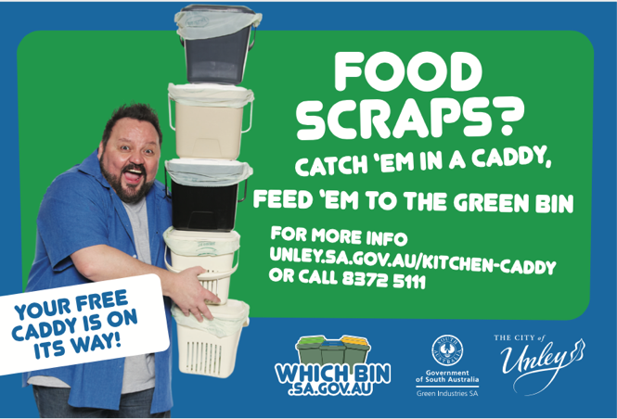
Educational flyer
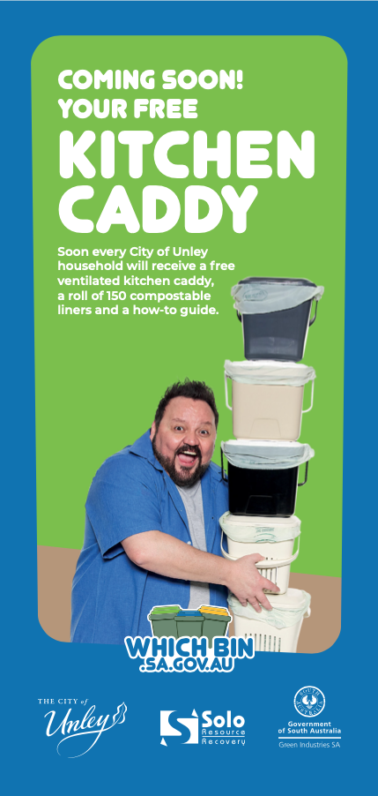 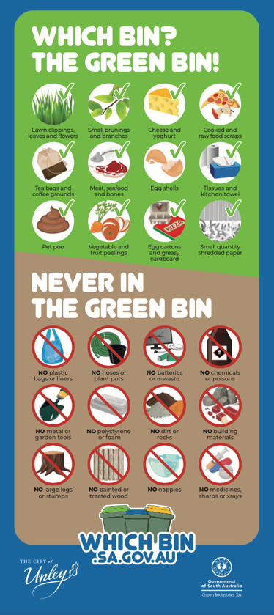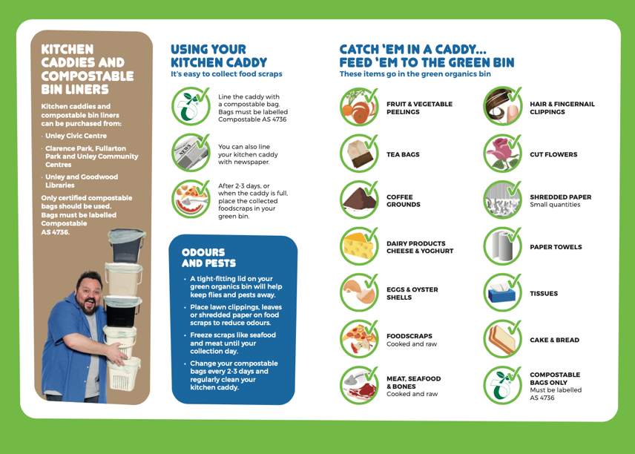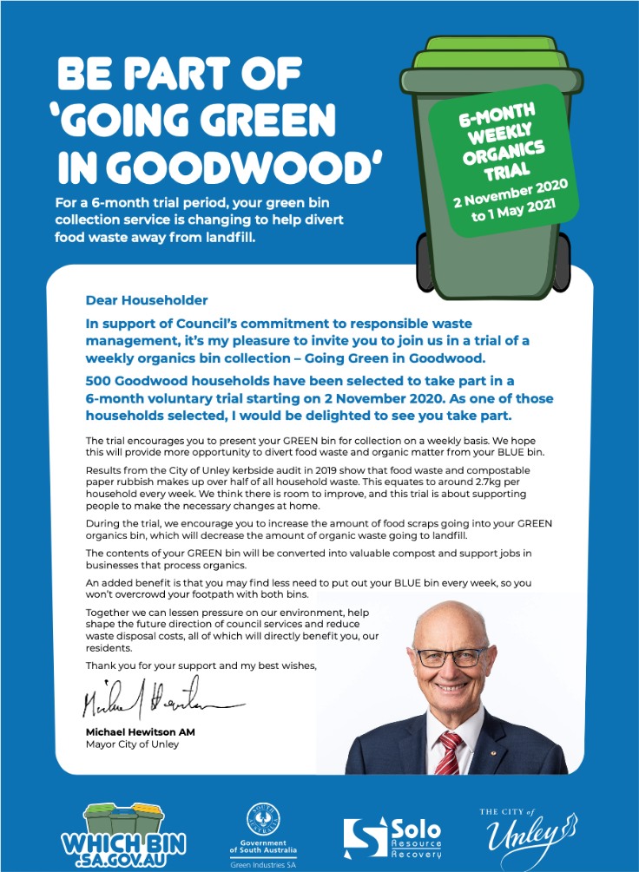
Information brochure for residents
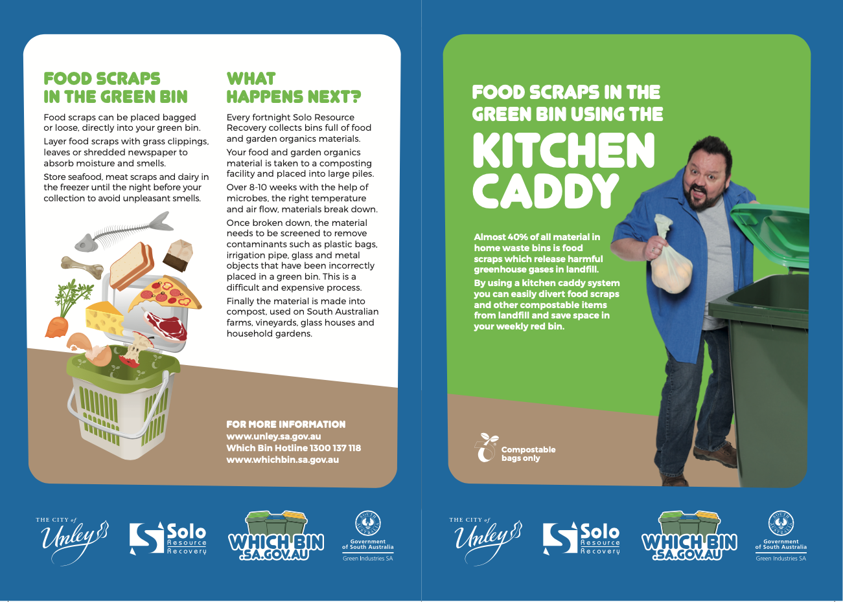

Kerbside collection or backyard composting
The Kerbside Performance Plus Food Organics Incentives are provided to encourage the diversion of food organics from the residual waste stream. Whilst a specifically designed kitchen-based food organics system is expected to achieve high participation and diversion rates, it will also involve some cost for the processing of putrescibles.
By comparison, backyard composting has a place in encouraging increased retention of food organics and other vegetative material on-site without further collection or processing costs. Where the use of home-based composting is proposed, Green Industries SA may consider providing an incentive payment, if the approach is supported by appropriate education and information. The program will contribute 50% toward the cost of home-based composting units (up to a maximum of $10) and the requirement for auditing of home composting systems is not required. Green Industries SA will require a list of residents that have taken up a council offer for a home composting unit as well as copies of educational materials and strategies related to this approach.
Total system costs
Applicants are encouraged to review the Business Case for Councils to Undertake Co-collection of Food Waste with Garden Organics report, available at www.greenindustries.sa.gov.au/_literature_179593/Business_case_for_councils_to_undertake_co-collection_of_food_waste_with_garden_organics_(2007)
This report outlines assumptions on various aspects of introducing a food organics system, as well as forecasts on potential yields that could be achieved.

What is the incentive offer?
South Australian councils can apply to Green Industries SA for funding under the Kerbside Performance Plus Food Organics Incentives on a ‘per serviced tenement’ basis.
Green Industries SA will provide up to 50% of the costs up to a maximum of $10 as an up-front payment with council needing to provide a satisfactory performance report within 12 months of the system roll-out. For councils introducing a high performing system (and achieving the performance target of a 1.3 kilogram reduction in the residual waste stream) level 2 payments will be available on a per tenement basis for up to five years. This program provides for an initial up-front payment, with a performance-based incentive available for up to five subsequent years. Total funds provided will depend on the system / approach adopted by council.

What are the conditions attached to the offer?
- Councils must enter into a signed grant agreement with Green Industries SA in which the council commits to introducing a food waste system.
- Where containerised systems (e.g. ventilated basket or caddy) are proposed, these must be used in conjunction with a green organics kerbside service at not less than a fortnightly basis.
- Support and maintain an approved service /approach with regular, on-going education and communications using template communication material for a minimum period of three years.

Other conditions
- A condition of funding for applicants receiving an up-front grant of $200,000 or more is to provide a kerbside waste and recycling audit report to Green Industries SA within 12 months of the introduction of a kerbside food organics collection service / approach. Audits are to be undertaken using the agency’s kerbside auditing methodology, including a representative sample of 100 bins for each kerbside stream. Audits are to be undertaken between 1 March and 31 May of the reporting year. For purposes of the diversion rate, calculations should not include hard refuse.
- A condition of funding is that organic material collected for processing/composting will only be processed at an appropriately licensed EPA facility, managed according to EPA and other planning requirements, and that the material is processed into soil improvement products that meet Australian Standard (where applicable) of which a significant portion is sold to third parties not affiliated with the collection company or processor.
- Community communications materials such as information brochures are to be checked by Green Industries SA before publication. Councils will be required to use template educational materials for on-going communications activity. This will remind householders of the availability of containers and bin liners in addition to how to use the system.
- Applicants should maintain the food organics system outlined in their application for at least five years.
- Councils failing to provide a performance report will be ineligible for further grants through Green Industries SA.

What is a ‘serviced tenement’?
A serviced tenement is usually a household, but may be a business if it is using the same kerbside waste and recycling service as surrounding households. The number of serviced tenements within a given council may be different for one component of the service when compared with another. For example, a council that provides an optional green organics service may have 26,000 serviced tenements for the residual waste service but only 18,000 serviced tenements for the green organics component. The incentive payment will be calculated and based on the serviced tenements actually receiving the prescribed service.

Contractual arrangements
Successful councils will be required to sign a grant agreement with Green Industries SA before receiving funding. The agreement will be for an initial five years and will set out the performance standards that the council has agreed to maintain for that period.
Councils with an existing food waste service are eligible for the level 2 performance-based payments (up to five years total subject to funding availability in years four and five), with payments to be facilitated through a new grant agreement.

Privacy and commercial-in-confidence considerations
All applications will be treated as commercial-in-confidence. Green Industries SA reserves the right to include third party evaluations as part of the assessment process and has the ultimate discretion in relation to publicity for applications. Applicants shall not publicise their projects without the approval of Green Industries SA.

Application of grant monies
Successful applicants will be required to apply grant funds to the roll-out and continued support of kerbside systems. While not a key feature of the grant assessment process, councils will be required to commit to applying grant funds in this way in order to ensure appropriate expenditure of waste levy-derived funds by Green Industries SA. This commitment forms part of the on-line declaration by the council and will be a requirement of the contract between the council and Green Industries SA.

Frequently Asked Questions
Q1. If I do not fully complete the relevant form, will it be assessed?
A. No. ALL sections of the application form must be fully completed for it to be assessed.
Q2. Will my application be accepted following the closure date?
A. Further rounds will be called depending on interest and uptake. Late applications will be held over to future calls; Councils will be given the opportunity to update these in preparation for the next round.
Q3. Can council seek funding for a redistribution of free bags?
A. Yes, the incentive provides for “reinvigoration” of existing area-wide systems, as well as blanket distribution of new systems with ventilated containers with a roll of 75 bags.
Q4 What if council’s proposal cost more than $10 per serviced tenement?
A. The grant payment will provide 50% of the total costs up to $10 per serviced tenement. GISA will meet 100% of the cost of the roll of 75 compostable bags in order to support maximum uptake of systems in 2020.
Q5. Do I need to submit a council resolution as part of the application?
A. No. However, before any payment is made by Green Industries SA details of a resolution and budget allocation will be required within three months to confirm that a grant application has been successful.

Assessment process
Applications will be assessed and prioritised based on the following essential criteria.
Essential criteria
- Does the project request no more than 50% funding contribution by Green Industries SA?
- Does the project use proven technology or technology that has been successfully demonstrated to pilot scale?
- Has council resolved to implement a food organics system, and are adequate funds set aside in the budget (if no, can you confirm when council will consider a report on food organics systems)?
- Does the project have a clear timetable for roll-out?
- What communications material will be provided, will communications be regular and on-going, and have sufficient funds been allocated in the budget proposal?
- Have quotes been provided for materials according to council’s purchasing policy?
- What is the expected diversion potential of the proposed system?

No project is guaranteed an allocation of funds by Green Industries SA. Funding through this program will be made entirely on a competitive basis, and Green Industries SA reserves the right to direct the funds to projects that are considered to be of most benefit.

Funding agreement
Successful applicants will be required to enter into a funding agreement with Green Industries SA. This agreement will set out the terms of the grant, conditions, payment schedules, project timing, key performance indicators, reporting requirements and other matters.
All required approvals, such as a council resolution, are to be provided within three months of the initial notification of the success of the application.
Green Industries SA must be acknowledged in all media and promotional activities relating to the project; the statement ‘this project has been funded by Green Industries SA’ or similar, would satisfy this requirement. Additional assistance may be provided where councils use the Which Bin brand. Copies of completed education material are to be provided to Green Industries SA.

Program overview
The Kerbside Performance Plus Food Organics Incentives Program assists councils to implement sustainable and efficient food organics recycling systems. It recognises that disposing food to landfill represents the loss of a potentially valuable resource and that when food organics are blended with kerbside green organic material, it improves the quality and nutrient value of the processed compost.
Submitting your application
Applications will be accepted until 5pm Adelaide time, 12 March 2021
Late or incomplete applications may not be accepted.
Please email your completed application, including all supporting documents to:
justin.lang@sa.gov.au with the subject line Kerbside Performance Incentives. Emails should not exceed 8MB.

Checklist
Before submitting your application, please check you have completed all the following:
- The application has been signed by an authorised officer.
- As much supporting information as possible, including detailed quotes for any goods.
- All quotes must include supplier details including ABN and any GST component.
- The application form in this document must be filled out completely and submitted by the Chief Executive (or delegated officer) of the council/subsidiary.

Need assistance?
Email justin.lang@sa.gov.au or telephone (08) 8204 2634 for more information.

1. Applicant Details
Name of the Organisation
ABN of the Organisation
Is Your Organisation (Tick one):
The lead organisation of a consortium or partnership? |  |  |  |  |  |  | The sole applicant?
If you are applying as the lead partner in this application, please give the names of the other organisations in the project.
Contact Details
Name of person dealing with this application
Title: | First name: |  | Last Name:
Job title of person named above
Tel No: |  | Mobile: |  |  |  | Fax:
E-mail:
Address for correspondence:
Address 1:
Address 2:
Town/Suburb: |  |  |  |  | Postcode:

2. Details of Kerbside Waste and Green Organics Services
Residual waste service | 140 L Capacity | Other _______
Residual waste collection frequency | weekly | fortnightly
Green organics collection frequency | Fortnightly | Weekly

3. Details of Proposed Food Organics System
Container manufacturer (supplier):  Contact details for supplier: | Name:  Address:  Phone:
Container type: | Ventilated (requiring compostable liner bags) | Non-ventilated (low priority in this round)
Number of services to be provided: | , Commercial premises  (round to nearest 50) | , Households  (round to nearest 100)
Estimated cost per container: | $ | Capacity: Litres
Was this price sought through a competitive tender process? | Yes, please provide details below of tender | No, please detail selection process to be undertaken
Tender / selection process:
What is council’s current disposal cost/tonne for residual waste? $
What is council’s current processing cost/tonne for organics? $

4. Project Summary
Please give a short description of the project (including method of providing bags where required).
Where required, how will bags be provided in subsequent years?

5. Proposed Budget (itemise all capital expenditure items)
Expenditure Item | Date | Funding Sought  (no more than 50%) | Applicant Contribution | Other Funding Sources (please specify) | Total Cost
Description | 20.7.21 | $ | $ | $ | $
Containers
Compostable liner bags (if required) |  |  | N/A
Education material – brochure
Education material – stickers/prompts
Distribution
Other
Totals: |  | $ | $ | $ | $
GISA funding as % of total funding:

6. Council Approval and Budget Allocations
If your application is approved, y
ou will need to provide details of Council resolutions and reports within 3 months of the signing of contracts, before grant funds are released. If already obtained, please attach a copy.
Has Council resolved to introduce a food organics system? | Yes | No
If yes, have you included details of the resolution and report? | Yes | No

7 Implementation Timeline
Action | Date
Order containers
Design of education material (consider using new GISA templates)
Initial communication to residents (e.g. Council newsletter)
Printing education materials
Shipping (delivery to central location)
Assembly and distribution of containers
Start collections

8. Contracts for Collection and Processing
Name of collection contractor
Contract in place for collection of organics: Yes/ No | Yes | Expiry date:
Name of organics processor:
Contract in place to accept organics? Yes/ No | Yes | Expiry date:

9. Communication and Consultation
Has a communications plan been prepared? |  | Yes, (please include/attach) | No
Please detail what community consultation has/will occur:
Please indicate below what efforts Council will be putting into education for the term of the Agreement with GISA.
Regular features in Council newsletters | Composting workshops
Web-based waste reduction information | Regular ads in local papers
Community education brochure | Social media
Tours of composting facilities | Other (please specify)
Which Bin resources requested (brochure, rates insert, DL fridge magnet, social media tiles – all in development)

10. Contact Person
Demonstration of technical expertise and capacity to manage project
(100 characters except Relevant Experience – 250 characters)
Name:
Position:
Role in this project:
Relevant experience/expertise:

Name:
Position:
Role in this project:
Relevant experience/expertise:

11. Declaration
I declare that the information on this application form and the supporting information enclosed with it are accurate to the best of my knowledge.
Signed
Name
Position |  | Chief Executive Officer
Date

The Chief Executive of your authority should sign the application form. It should not be signed by the contact person/s unless they are one and the same.

